FACULTY PROFILE

Name of the Faculty: |  |  | S.L.V.MALLIKARJUN |  |  |  | 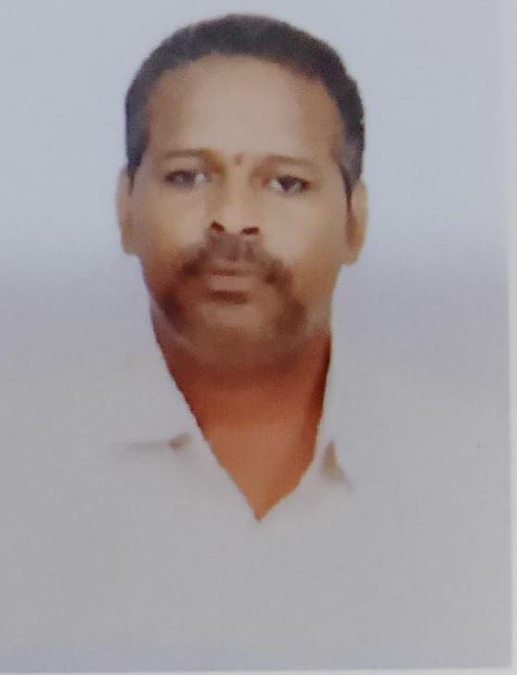
Designation: |  |  | ASSISTANT PROFESSOR
Department: |  |  | PHYSICS
Date of Birth: |  |  | 20-08-1974
AICTE – ID:
Education | - B.Sc ( M.P.C ) from Acharya Nagarjuna University in 1994  - M.Sc (Physics) with Solid state physics Specialization from S.V University-Tirupati in 1996  - M.Phil in Thin film physics specialization from S.V University-Tirupati in 1999
Experience | Teaching: 23 Years |  |  |  | Industry: __-__Years | Total: ___24.5__Years
 | Research: 1.5 Years |  |  |  | Others: ____Years
Research Specialization
Courses taught |  | 1.M.Sc (PHYSICS)  2.FIRST YEAR B.TECH PHYSICS  3.  4.
Research contributions

International/national peer reviewed journals

S. No. | Title of paper | Journal | Year | Volume | pages | Indexing (SCI/WoS/ SCOPUS, Google scholar)
1
2
3

Books published
S. No. | Title of the book | Publisher | year
1 | B.Sc (PHYSICS) I, II & III- YEAR | VIKAS | 2016
2 | B.Sc(PRACTICAL PHYSICS) ) I, II & III- YEAR | TECHNICAL | 2017

Book chapters Published

S.No. | Title of the Chapter | Book title | Publisher | year
1

Details of Patents (Filed & Granted)

S. No. | Applications number | Title of the patent | Date of filing/publishing | Published/granted
1

Details of Conferences/FDPs/STTPs/webinars/Workshops Organized

S.No. | Name of the event | Role | Dates
1

Details of Conferences/FDPs/STTPs/webinars/Workshops Participated

S.No. | Name of the event | Organized by | Dates
1

Awards/recognitions/achievements

S.No. | Name of the Award | Awarding body/Society/Organization | Year
1

Details of project proposals submitted/sanctioned/completed

S.No. | Title of the Project | Funding body | Submitted/ Sanctioned/ Completed | Amount | Year/ duration

Consultancy contribution

S.No. | Year | Amount | Details
1

Student Project/research guidance

S.No | Level | Total number
1 | UG | Completed: Ongoing:
2 | PG | Completed: 2 Ongoing:
3 | PhD | Completed: Ongoing:

Administrative experience

S.No. | Role | Duration (From – to)
1 | EXAMINATION OFFICER | 2010-2022
2 | FIRST YEAR B.TECH CO-OEDINATOR | 2014-2022
3 | RESULT ANALYSIS FOR ALL BRANCHES | 2016 – TILL NOW
4 | TIME TABLE INCHARGE | 2014-2018, 2020-2022
5 | BECAP COORDINATOR | 2022 ONWARDS
6 | EXECUTING INTERNAL MARKS FOR ALL SECTIONS, PROGRESS REPORTS | 2014 ONWARDS
7 | LIBRARY COMMITTEE MEMBER | 2018 ONWARDS

Research credentials

Index/database | ID/Link
Google Scholar
SCOPUS
Web of Science
Vidwan ID

Any other relevant information

SLV Mallikarjun
14-09-2023

