FACULTYPROFILE

Nameofthe Faculty: |  |  | YAZALI CHAITANYA |  |  |  | 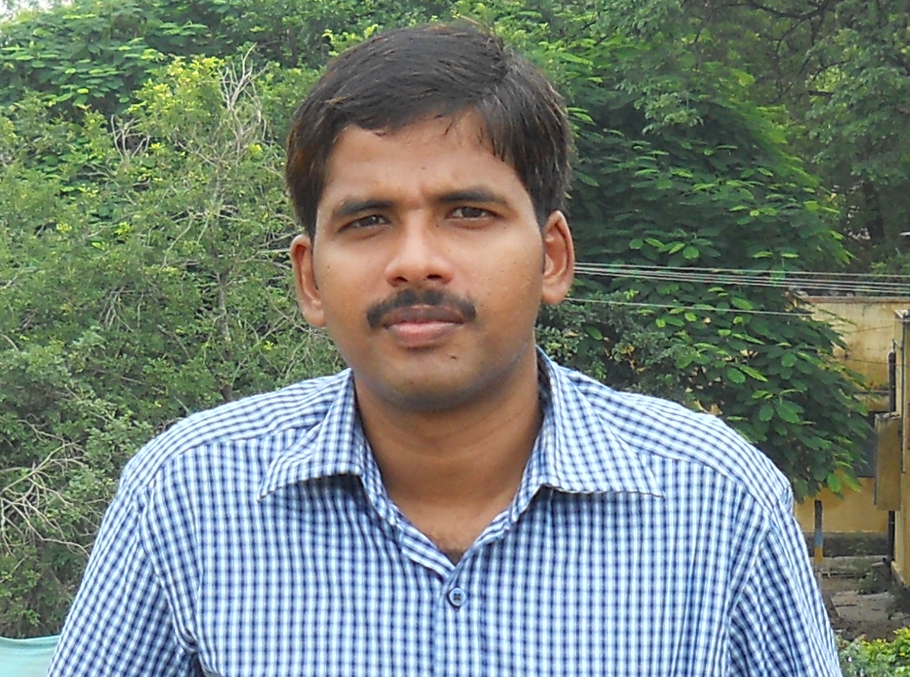
Designation: |  |  | ASSISTANT PROFESSOR
Department: |  |  | PHYSICS
Dateof Birth: |  |  | 08-03-1980
AICTE– ID: | 1-1515271944
Education | - B.Sc in Physics from Acharya Nagarjuna University in 2001  - M.Sc in Solid State Physics Specialization from Acharya Nagarjuna University in 2003  - M.Phil in Crystal Growth specialization from Sardar Patel University 2006
Experience | Teaching: 17 Years |  |  |  | Industry:____Years | Total: 19 Years
 | Research: 2 Years |  |  |  | Others:____Years
ResearchSpecialization |  |  |  | Crystal Growth  Glass Science
Courses taught |  | 1. B.TECH  2. M.SC
Research contributions

International/national peer reviewed journals

S. No. | Title of paper | Journal | Year | Volume | pages | Indexing (SCI/WoS/ SCOPUS, Google scholar)
1 | Monetization of Coma patient and Health prediction using machine learning | Journal of Engineering Sciences | march’20 | Vol 11,Issue 3 | :275-282
2 | Microstructural, Crystal Growth, EDAX, FTIR studies of ADP crystals prepared through aqueous solution method | Journal of Xidian University | May’20 | VOLUME 14, ISSUE 5, | 127-135
3 | Crystal Growth, Morphological, EDAX, FTIR studies of KDP crystals prepared through aqueous solution method | Journal of Xidian University | April’20 | VOLUME 14, ISSUE 4, | 402 – 408
4 | The influence of Cu2+ ions on the ionic, electronic conductivity and optical characteristics of Li2O-SrO-B2O3 system | J.Non. Crystalline solids | October’21 | volume 575 | 121210 | Scopus -3.5
5 | Impact of copper ions on physical, structural, spectroscopic, and dielectric properties of Bi2O3–CaO–P2O5–B2O3 glasses | Materials Chemistry and Physics | October 2022, | Volume 290, 15 | 126584 | Scopus- 4.778

Bookspublished

S. No. | Title of the book | Publisher | year
1

Book chaptersPublished

S.No. | Title of the Chapter | Book title | Publisher | year
1

Details of Patents(Filed&Granted)

S. No. | Applications number | Title of the patent | Date of filing/publishing | Published/granted
1

Details of Conferences/FDPs/STTPs/webinars/WorkshopsOrganized

S.No. | Name of the event | Role | Dates
1

Details of Conferences/FDPs/STTPs/webinars/Workshops Participated

S.No. | Name of the event | Organized by | Dates
1 | Advanced NDT Techniques & Applications in Industry | Department of Mechanical Engineering, QISCET, Ongole | 25th-29th may’20
2 | National level FDP on SCILAB | St.PETER’s Engineering College and IIT BOMBAY | 15th-19th June’20
3 | Materials for Energy and Biomedical  Applications | Department of Basic Science and  Humanities, GMR Institute of Technology, Rajam | 31st May - 04th June, 2021
4 | Nano  materials-Technologies for Energy & Sensor Applications | Chemistry Division, Department of Basic Sciences & Humanities, GMR  Institute of Technology, Rajam | 7th to 11th, June 2021
5 | Online Teaching- Learning And Research Methodology | Govt. P. G. College, Bilaspur  Rampur - Uttar Pradesh | July 18 - July 29, 2020
6 | First International Virtual Conference On Nanomaterials, FIVCON-2020 | Acharya Nagarjuna University | 10th – 12th  September, 2020
7 | Inculcating  Universal Human Values in Technical Education | AICTE | 21-25 September, 2020
8 | BASIC RESEARCH AND ANALYSIS IN NANOSCIENCE | Acharya Nagarjuna University | 18th & 19th March, 2021
9 | Two weeks international workshop on Emerging trends in the field of Science and Technology | Satyabhama Institute of Science and Technology | 16th-28th August,2021
10 | Novel Nanomaterials-based Flexible and Wearable Devices for Healthcare Aplications | VIT | 5th-9th July.2021
11 | Outcome Based Education and Examination Reforms (OBE &  ER - 2022) | BAPTLA ENGINEERING COLLEGE | 03rd-5th August 2022
12 | Outcome Based Curriculum Design | NITTTR, Chandigarh | 5th-9th September,2022
13 | Two day Workshop on RESEARCH METHODOLOGIES AND SCIENTIFIC PUBLISHING | BAPTLA ENGINEERING COLLEGE | 28th-29th October,2022
14 | Nanomaterials For Sustainable Future | Physics  Division, Department of Basic Science and Humanities, GMR Institute of Technology, Rajam | 12th - 16th December, 2022
15 | Preparing Students for the Placements - Resume, GD and Interview | NITTTR, Chandigarh | 17th-21st July 2023

Awards/recognitions/achievements

S.No. | Name of the Award | Awarding body/Society/Organization | Year
1

Details of project proposals submitted/sanctioned/completed

S.No. | Title of the Project | Funding body | Submitted/ Sanctioned/ Completed | Amount | Year/ duration

Consultancy contribution

S.No. | Year | Amount | Details
1

Student Project/research guidance

S.No | Level | Total number
1 | UG | Completed: Ongoing:
2 | PG | Completed: Ongoing:
3 | PhD | Completed: Ongoing:

Administrative experience

S.No. | Role | Duration (From – to)
1 | Department CCA Co-Ordinator | 2012 to till date
2 | Department library Co-Ordinator | 2012 to till date

Research credentials

Index/database | ID/Link
Google Scholar | https://scholar.google.com/citations?user=DbaqpjkAAAAJ&hl=en&oi=sra
SCOPUS | 57291240800
Web of Science
Vidwan ID

Any other relevant information

Y.Chaitanya
(Date)

