FACULTY PROFILE
Name of the Faculty: |  |  | Challa Ramesh |  |  |  | 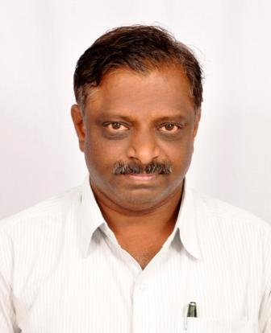
Designation: |  |  | Professor
Department: |  |  | EIE
Date of Birth: |  |  | 29-12-1967
AICTE – ID: | 1-424721292
Education | - M.Tech in [Electronic Instrumentation] with [First Class] from REC Warangal, [Tirupati], [From 1990 – To 1992].  - B.Tech in [ECE] with [First Class] from [JNTU Hyderabad ], [Hyderabad], [From 1985 – To 1989].
Experience | Teaching: [28 Years] |  |  |  | Industry: [Years] | Total: 28 Years
 | Research: [Years] |  |  |  | Others: [Years]
Area of Specialization |  |  |  | Antennas
Course Work |  | Data Structures, OOPs Through Java, Signals and Systems, Microprocessors and Microcontrollers.
Details of Ph.D. Scholars /Masters Level Projects :-
 | Completed | Ongoing
Ph.D. guided
Master Projects

Details of ResearchPublication :-
 | International | National
Research Publications
Research Presentations

Details of Sponsored Projects/Consultancy :-
 | Completed | Ongoing | Amount to be earned
Sponsored Projects
Consultancy Works

No of Books Published :-
No of Patents (Filed & Granted) :-
No of FDPs & Workshops Attended: FDPs-11, WORKSHOPs-4

