FACULTYPROFILE

Nameofthe Faculty: |  |  |  |  |  | D.NIRANJAN BABU |  |  |  |  |  |  |  |  |  | 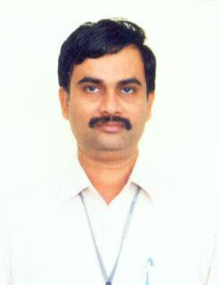
Designation: |  |  |  |  |  | PROFESSOR
Department: |  |  |  |  |  | EIE
Dateof Birth: |  |  |  |  |  | 14/08/1969
AICTE– ID:
Education |  | - [PG] in [M.TECH](EICS) with [First Division] from [ S.V.University], [TIRUPATI]  - [UG] in [B.TECH (ECE )] with [First Division] from [J.N.T.U. COOLEGE OF ENGINEERING ], [ANANTAPUR]
Experience |  | Teaching: 27Years |  |  |  |  |  |  | Industry:- |  |  |  |  |  | Total: 30Years
 |  | Research: -- |  |  |  |  |  |  | Others:- 3
AreaofSpecialization |  |  |  |  |  |  | Electronic Instrumentation and Communication Systems
CourseWork: |  |  | Taught more than 25 subjects for 2nd , 3rd ,4th year B.Tech ( EIE& ECE) and M.Tech ( CESP) students
DetailsofPh.D.Scholars/MastersLevelProjects: -
 |  |  |  |  |  |  |  |  |  | Completed |  |  | Ongoing
 |  |  |  |  | Ph.D.guided
 |  |  |  |  | MasterProjects |  |  |  |  | 5
DetailsofResearch Publications: -
 |  |  |  |  |  |  |  |  |  |  | International |  |  | National
 |  |  |  | ResearchPublications
 |  |  |  | ResearchPresentations
DetailsofSponsoredProjects/Consultancy: -
 |  |  |  |  |  |  |  | Completed |  |  | Ongoing | Amounttobeearned
 | SponsoredProjects |  |  |  |  |  |  | - |  |  | - | -
 | ConsultancyWorks |  |  |  |  |  |  | - |  |  | - | -
No ofBooksPublished: ---
NoofPatents(Filed&Granted):---
No ofFDPs&WorkshopsAttended: 4

