**OPTICAL COMMUNICATIONS (18EC703)**

**UNIT – I**

INTRODUCTION: Historical development, The general system, Advantages of Optical Fiber communications, OPTICAL FIBER WAVEGUIDES: Introduction, RAY THEORY TRANSMISSION: Total internal reflection, Acceptance angle, Numerical Aperture, Skew rays. CYLINDRICAL FIBER: Modes, Mode coupling, Step index fibers, Graded index fibers, Fiber materials.

**Introduction:**

* Communication may be broadly defined as the transfer of information from one point to another.
* When the information is to be conveyed over any distance a communication system is usually required.
* Within a communication system the information transfer is frequently achieved by superimposing or modulating the information onto an electromagnetic wave which acts as a carrier for the information signal. This modulated carrier is then transmitted to the required destination where it is received and the original information signal is obtained by demodulation.
* Sophisticated techniques have been developed for this process using electromagnetic carrier waves operating at radio frequencies as well as microwave and millimeter wave frequencies.
* However, ‘communication’ may also be achieved using an electromagnetic carrier which is selected from the optical range of frequencies.
* Fiber-optic communication is a method of transmitting information from one place to another by sending pulses of light through an optical fiber. The light forms an electromagnetic carrier wave that is modulated to carry information.
* Fiber Optics is a branch of optics that deals with the study of propagation of light through transparent dielectric waveguide.
* An optical fiber is a glass or plastic fiber that carries light along its length.
* Fiber is preferred over electrical cabling when high bandwidth, long distance, or immunity to electromagnetic interference are required.
* This type of communication can transmit voice, video, and telemetry through local area networks, computer networks, or across long distances.

**Historical Development:**

* The use of visible optical carrier waves or light for communication has been common for many years. In 1880 Alexander Graham Bell reported the transmission of speech using a light beam.
* its use was limited to mobile low-capacity communication links. This was due to both the lack of suitable light sources and the problem that light transmission in the atmosphere is restricted to line of sight and is severely affected by disturbances such as rain, snow, fog, dust and atmospheric turbulence.
* A renewed interest in optical communication was stimulated in the early 1960s with the invention of the laser. This device provided a powerful coherent light source, together with the possibility of modulation at high frequency.
* The invention of the laser instigated a tremendous research effort into the study of optical components to achieve reliable information transfer using a lightwave carrier. The proposals for optical communication via dielectric waveguides or optical fibers fabricated from glass to avoid degradation of the optical signal by the atmosphere were made almost simultaneously in 1966 by Kao and Hockham and Werts. Such systems were viewed as a replacement for coaxial cable or carrier transmission systems. Initially the optical fibers exhibited very high attenuation (i.e. 1000 dB km−1 ) and were therefore not comparable with the coaxial cables they were to replace (i.e. 5 to 10 dB km−1 ). There were also serious problems involved in jointing the fiber cables in a satisfactory manner to achieve low loss and to enable the process to be performed relatively easily and repeatedly in the field. Nevertheless, within the space of 10 years optical fiber losses were reduced to below 5 dB km−1 and suitable low-loss jointing techniques were perfected.
* In parallel with the development of the fiber waveguide, attention was also focused on the other optical components which would constitute the optical fiber communication system. Since optical frequencies are accompanied by extremely small wavelengths, the development of all these optical components essentially required a new technology. Thus semiconductor optical sources (i.e. injection lasers and light-emitting diodes) and detectors (i.e. photodiodes and to a lesser extent phototransistors) compatible in size with optical fibers were designed and fabricated to enable successful implementation of the optical fiber system. Initially the semiconductor lasers exhibited very short lifetimes of at best a few hours, but significant advances in the device structure enabled lifetimes greater than 1000 h and 7000 h to be obtained by 1973 and 1977 respectively.
* Later in 1980, optical systems operates at 90Mbps.Todays systems operate at 10Gbps and beyond. Advancement in technology and introduction of DWDM(Dense Wavelength Division Multiplexing) and EDFA (Erbium-Doped Fiber Amplifier) data rates go beyond terabit per sec. over distance in excess of 100km.

**The general System:**

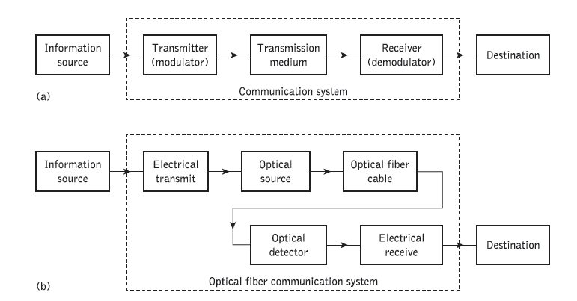

Fig.(a) : The general communication system. Fig.(b): The optical fiber communication system

An optical fiber communication system is similar in basic concept to any type of communication system. A block schematic of a general communication system is shown in Fig.(a), the function of which is to convey the signal from the information source over the transmission medium to the destination.

1. The communication system therefore consists of a transmitter or modulator linked to the information source, the transmission medium, and a receiver or demodulator at the destination point.
2. In electrical communications the information source provides an electrical signal, usually derived from a message signal which is not electrical (e.g. sound), to a transmitter comprising electrical and electronic components which converts the signal into a suitable form for propagation over the transmission medium.
3. The transmission medium can consist of a pair of wires, a coaxial cable or a radio link through free space down which the signal is transmitted to the receiver, where it is transformed into the original electrical information signal (demodulated) before being passed to the destination.
4. However, it must be noted that in any transmission medium the signal is attenuated, or suffers loss, and is subject to degradations due to contamination by random signals and noise, as well as possible distortions imposed by mechanisms within the medium itself.
5. Therefore, in any communication system there is a maximum permitted distance between the transmitter and the receiver beyond which the system effectively ceases to give intelligible communication.
6. For longhaul applications these factors necessitate the installation of repeaters or line amplifiers at intervals, both to remove signal distortion and to increase signal level before transmission is continued down the link.

**Optical Fiber Communication system is shown in fig.(b)**

In this case the information source provides an electrical signal to a transmitter comprising an electrical stage which drives an optical source to give modulation of the lightwave carrier. The optical source which provides the electrical–optical conversion may be either a semiconductor laser or light-emitting diode (LED). The transmission medium consists of an optical fiber cable and the receiver consists of an optical detector which drives a further electrical stage and hence provides demodulation of the optical carrier. Photodiodes (*p*–*n*, *p*–*i*–*n* or avalanche) and, in some instances, phototransistors and photoconductors are utilized for the detection of the optical signal and the optical–electrical conversion.

The optical carrier may be modulated using either an analog or digital information signal. In the system shown in fig.(b) analog modulation involves the variation of the light emitted from the optical source in a continuous manner. With digital modulation, however, discrete changes in the light intensity are obtained (i.e. on–off pulses). Although often simpler to implement, analog modulation with an optical fiber communication system is less efficient, requiring a far higher signal-to-noise ratio at the receiver than digital modulation. Also, the linearity needed for analog modulation is not always provided by semiconductor optical sources, especially at high modulation frequencies. For these reasons, analog optical fiber communication links are generally limited to shorter distances and lower bandwidth operation than digital links.

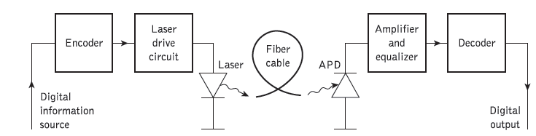

Fig.(c):A digital fiber optic link

Initially, the input digital signal from the information source is suitably encoded for optical transmission. The laser drive circuit directly modulates the intensity of the semiconductor laser with the encoded digital signal. Hence a digital optical signal is launched into the optical fiber cable. The avalanche photodiode (APD) detector is followed by a front-end amplifier and equalizer or filter to provide gain as well as linear signal processing and noise bandwidth reduction. Finally, the signal obtained is decoded to give the original digital information.

**Advantages of Optical Fiber Communications:**

***1. Enormous potential bandwidth:***

Information carrying capacity of transmitter system is directly proportional to carrier frequency of transmitted signals.

The optical carrier frequency in the range 1013 to 1016 Hz yields a far greater

potential transmission bandwidth than metallic cable systems (i.e. coaxial cable bandwidth typically around 20 MHz over distances up to a maximum of 10 km) or even millimeter wave radio systems (i.e. systems currently operating with modulation bandwidths of 700 MHz over a few hundreds of meters).

***2. Small size and weight***:

Optical fiber have very small diameter which are often no greater than the diameter of human hair. Small size and light weight property of an optical fiber is somewhat advantageous in various applications like aircraft, satellites and even ships.

***3. Electrical isolation:***

Optical fibers which are fabricated from glass or sometimes a plastic polymer are electrical insulator, they do not exhibit earth loop and interface problems. Hence no hazards of short circuit as in metal wires.

***4.Immunity to interference and crosstalk***:

Optical fibers form a dielectric waveguides and are therefore free from electromagnetic interference (EMI), radio frequency (RF), etc. Hence the operation of an optical fiber communication system is unaffected by transmission through an electrically noisy environment and fiber cable requires no shielding from EMI.

***5.Signal security:***

The light from optical fibers does not radiate significantly and therefore they provide a high degree of signal security:

***6.Low transmission loss:***

Fibers have been fabricated with losses as low as 0.2dB/km and this feature has become a major advantage of optical fiber communication.

***7.System reliability and ease of maintenance:***

The low loss property of optical fiber cable reduces the requirement for intermediate repeaters or line amplifiers to boost the transmitted signal strength. Hence with fewer repeaters the system reliability is greatly enhanced. High reliability reduces its expenditure on maintenance.

***8.Ruggedness and Flexibility:***

Optical fibers have a very high tensile strength. The fibers may also be bent to quite small radii or twisted without damage.

***9.Low cost and availability:***

The fibers are made from silica which is available in abundance. Hence there is no shortage of material and its cost is also less. So optical fiber offers a very low cost communication.

**Disadvantages of Optical Fiber Communications:**

* Fiber optic cables are difficult to splice. Fiber optic splicing is the joining two fiber optic cables together. There can be data loss due to fiber optic cable splicing.
* Because of the physical nature of fiber optic cables, it can be damaged easily.
* If you bend fiber optic cables beyond a limit, it will break.
* Fiber optic cable is expensive to install. It needs costly splicing machines and trained specialists to install fiber optic cables.
* Its economical only when the entire bandwidth is fully utilized.
* Only point to point communication is possible.

**Applications of Optical Fiber Communications:**

The optical fibers have many applications. Some of them are as follows –

1. Used in telephone systems
2. Used in sub-marine cable networks
3. Used in data link for computer networks, CATV Systems
4. Used in CCTV surveillance cameras
5. Used for connecting fire, police, and other emergency services.
6. Used in hospitals, schools, and traffic management systems.
7. Fibre optic cables transmit large amounts of data at very high speeds. This technology is therefore widely used in internet cables. As compared to traditional copper wires, fibre optic cables are less bulky, lighter, more flexible, and carry more data.
8. With the high level of data security required in military and aerospace applications, fibre optic cables offer the ideal solution for data transmission in these areas.
9. Fibre optic cables are widely used in the fields of medicine and research. Optical communication is an important part of non-intrusive surgical methods, popularly known as endoscopy. In such applications, a minute, bright light is used to light up the surgery area within the body, making it possible to reduce the number and size of incisions made.

**Structure of Optical fiber:**

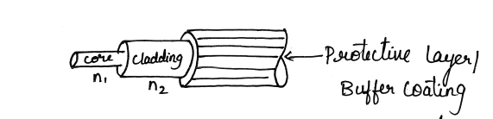

1. An optical fiber is a cylindrical waveguide operating at optical frequencies.
2. Dielectric cylinder of radius ‘a’ and refractive index n1 is known as core of fiber.
3. Core is surrounded by glass of slightly lower refractive index n2 (n2<n1) known as cladding.
4. The cladding performs the following functions:

• Reduces loss of light from the core into the surrounding air • Reduces scattering loss at the surface of the core • Protects the fiber from absorbing surface contaminants • Adds mechanical strength.

1. For extra protection, the cladding is enclosed in an additional layer called the coating or buffer.
2. The coating or buffer is a layer of material used to protect an optical fiber from physical damage. The material used for a buffer is a type of plastic. The buffer is elastic in nature and prevents abrasions. The buffer also prevents the optical fiber from scattering losses caused by microbends. Microbends occur when an optical fiber is placed on a rough and distorted surface.

**Refractive Index**

The refractive index is expressed as the ratio of the velocity of light in free space to the velocity of light in the medium.

**n=c/v**

The refractive index for vacuum and air is 1.0 for water it is 1.3 and for glass refractive index is 1.5

**RAY THEORY TRANSMISSION:**

**Total Internal Reflection:**

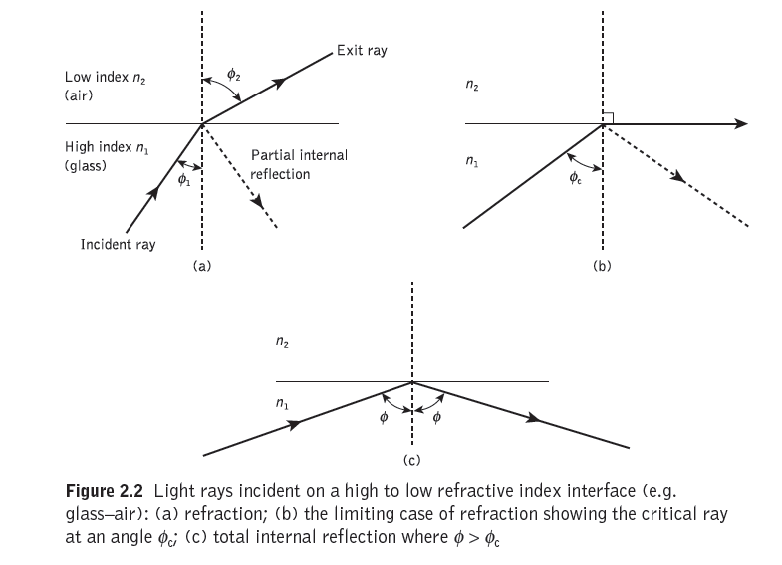

When a ray is incident on the interface between two dielectrics of differing refractive indices (e.g. glass–air), refraction occurs, as illustrated in Figure 2.2(a). It may be observed that the ray approaching the interface is propagating in a dielectric of refractive index *n*1 and is at an angle φ1 to the normal at the surface of the interface. If the dielectric on the other side of the interface has a refractive index *n*2 which is less than *n*1, then the refraction is such that the ray path in this lower index medium is at an angle φ2 to the normal, where φ2 is greater than φ1. The angles of incidence φ1 and refraction φ2 are related to each other and to the refractive indices of the dielectrics by **Snell’s law of refraction** which states that:



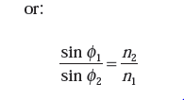 (1)

It may also be observed in Figure 2.2(a) that a small amount of light is reflected back into the originating dielectric medium (partial internal reflection). As *n*1 is greater than *n*2, the angle of refraction is always greater than the angle of incidence. Thus when the angle of refraction is 90° and the refracted ray emerges parallel to the interface between the dielectrics, the angle of incidence must be less than 90°. This is the limiting case of refraction and the angle of incidence is now known as the **critical angle φc**, as shown in Figure 2.2(b).

From equation (1) ,we can say that

Φ1 = φ c , φ2 = 90°

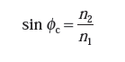

Φc= sin-1(n2/n1)

At angles of incidence greater than the critical angle the light is reflected back into the originating dielectric medium (total internal reflection) with high efficiency (around 99.9%). Hence, it may be observed in Figure 2.2(c).

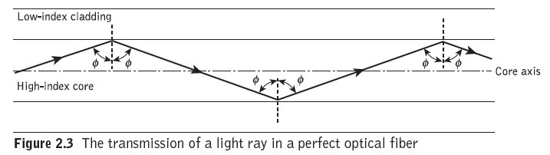

Figure 2.3 illustrates the transmission of a light ray in an optical fiber via a series of total internal reflections at the interface of the silica core and the slightly lower refractive index silica cladding. The ray has an angle of incidence φ at the interface which is greater than the critical angle and is reflected at the same angle to the normal.

The light ray shown in Figure 2.3 is known as a **meridional ray** as it passes through the axis of the fiber core. This type of ray is the simplest to describe and is generally used when illustrating the fundamental transmission properties of optical fibers.

It must also be noted that the light transmission illustrated in Figure 2.3 assumes a perfect fiber, and that any discontinuities or imperfections at the core–cladding interface would probably result in refraction rather than total internal reflection, with the subsequent loss of the light ray into the cladding.

**Acceptance angle:**

It is the angle at which light ray must enter the optical fiber to undergo total internal reflection.

The geometry concerned with launching a light ray into an optical fiber is shown in

Figure 2.4

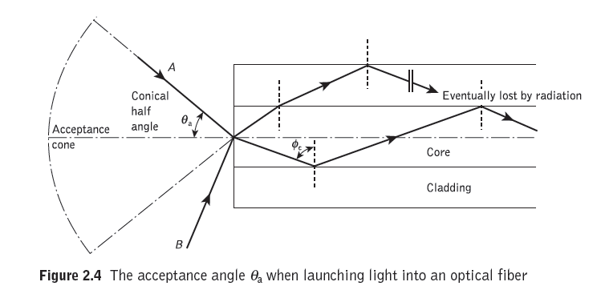

It may be observed that ray ‘A’ enters the fiber core at an angle θa to the fiber axis and is refracted at the air–core interface before transmission to the core–cladding interface at the critical angle.

Hence, any rays which are incident into the fiber core at an angle greater than θa will be transmitted to the core–cladding interface at an angle less than φc, and will not be totally internally reflected. This situation is also illustrated in Figure 2.4, where the incident ray ‘*B’* at an angle greater than θa is refracted into the cladding and eventually lost by radiation.

Thus for rays to be transmitted by total internal reflection within the fiber core they must be incident on the fiber core within an acceptance cone defined by the conical half angle θa. Hence θa is the maximum angle to the axis at which light may enter the fiber in order to be propagated, and is often referred to as the **acceptance angle** for the fiber.

**Numerical Aperture (NA):**

Numerical Aperture is the light gathering capability of an optical fiber.

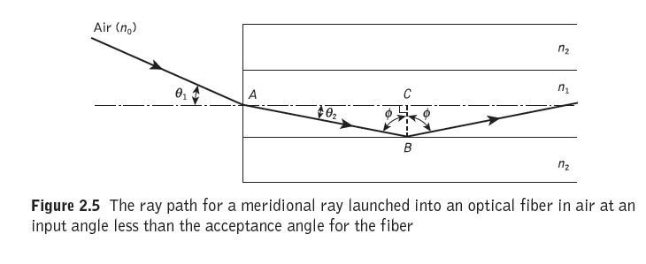 Figure 2.5 shows a light ray incident on the fiber core at an angle ϴ1 to the fiber axis which is less than the acceptance angle for the fiber ϴa. The ray enters the fiber from a medium (air) of refractive index *n*0, and the fiber core has a refractive index *n*1, which is slightly greater than the cladding refractive index *n*2

considering the refraction at the air–core interface and using **Snell’s law**

** (1)**

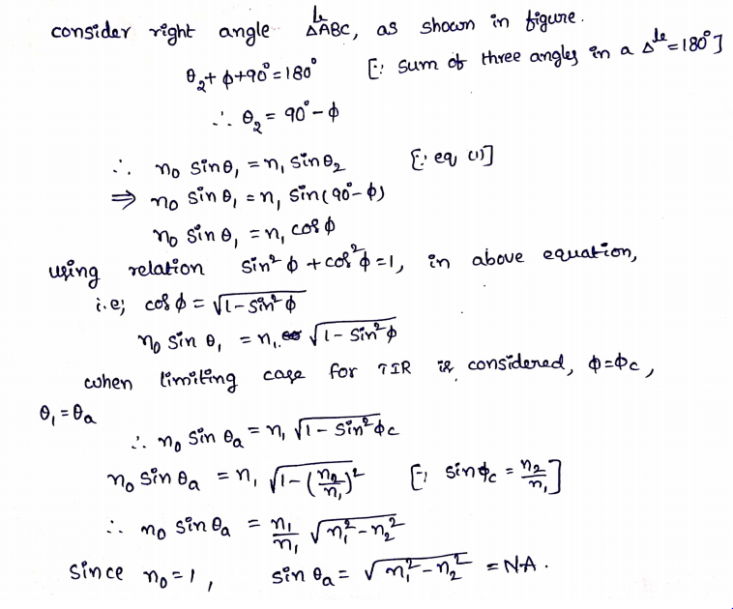

Therefore, ϴa = sin-1 (NA)

The *NA* may also be given in terms of the relative refractive index difference Δ between the core and the cladding which is defined as

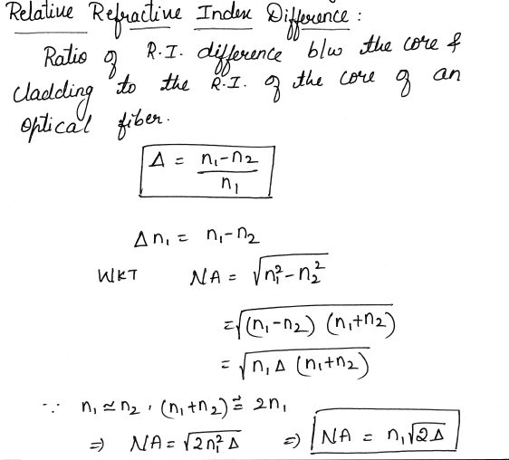

**For Problems refer your class notes.**

**Meridional Rays & Skew rays**

Two types of rays can propagate along an optical fiber. The first type is called meridional rays. **Meridional rays are rays that pass through the axis of the optical fiber.** Meridional rays are used to illustrate the basic transmission properties of optical fibers. The second type is called skew rays. **Skew rays are rays that travel through an optical fiber without passing through its axis**.

**MERIDIONAL RAYS**— Meridional rays can be classified as **bound or unbound rays.** Bound rays remain in the core and propagate along the axis of the fiber. Bound rays propagate through the fiber by total internal reflection. Unbound rays are refracted out of the fiber core.

Figure 2-10 shows a possible path taken by bound and unbound rays in a step-index fiber. The core of the step-index fiber has an index of refraction n1. The cladding of a step-index has an index of refraction n2, that is lower than n1. The below figure assumes the core-cladding interface is perfect. However, imperfections at the core-cladding interface will cause part of the bound rays to be refracted out of the core into the cladding. The light rays refracted into the cladding will eventually escape from the fiber. In general, meridional rays follow the laws of reflection and refraction.

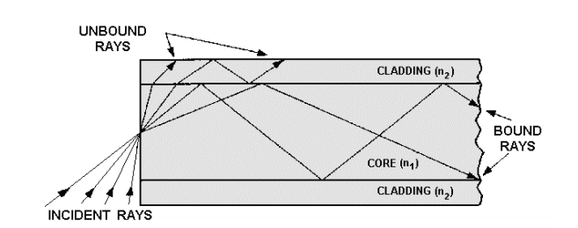

Fig. Bound and unbound rays with in a step index fiber

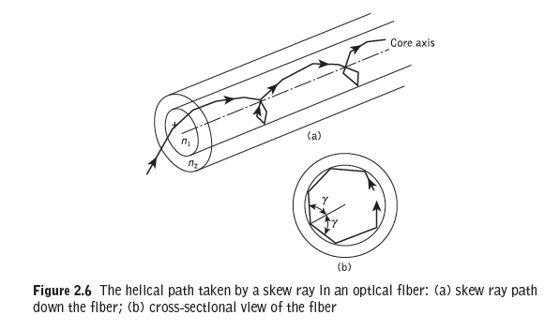

* Skew rays propagate without passing through the center axis of the fiber.
* The acceptance angle for skew rays is larger than the acceptance angle of meridional rays.
* Skew rays follow a helical path through the fiber. It may be observed from Figure 2.6(b) that the helical path traced through the fiber gives a change in direction of 2γ at each reflection, where γ is the angle between the projection of the ray in two dimensions and the radius of the fiber core at the point of reflection.
* Acceptance angle for skew rays

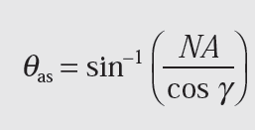

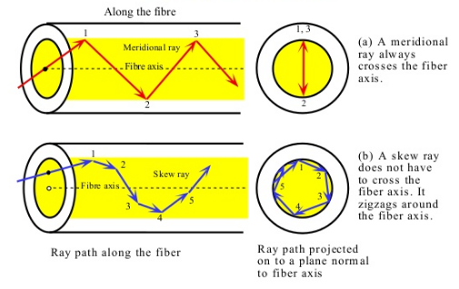

**Axial Rays:**

A light ray that travels along the optical axis.

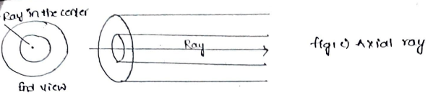

**Mode Theory**

* The mode theory uses electromagnetic wave behavior to describe the propagation of light along a fiber.
* Waveguide mode stands for a unique distribution of transverse and longitudinal components of the electric and magnetic fields. There are two types of waveguide modes that can propagate in the waveguides: TE (Transverse Electric) and TM (Transverse Magnetic).
* In TE modes only transverse (perpendicular to the direction of propagation) electric field exists and there is no longitudinal (along propagation direction) component, and the magnetic field exists in all directions.
* For TM modes we deal with only transverse magnetic field and the electric field exists in all directions.

**Normalized frequency or V-Number:**

The normalized frequency determines how many modes a fiber can support. Normalized frequency is a dimensionless quantity. Normalized frequency is also related to the fiber's cutoff wavelength. Normalized frequency (V) is defined as:

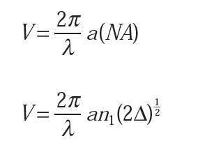



**Mode Coupling:**

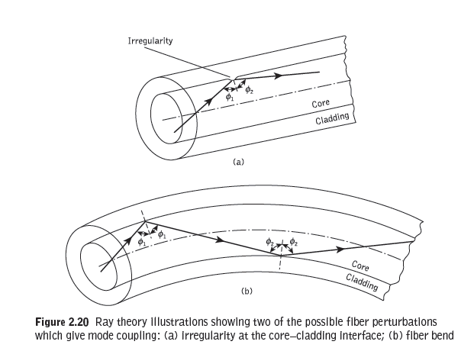

We have thus far considered the propagation aspects of perfect dielectric waveguides. However, waveguide perturbations such as deviations of the fiber axis from straightness, variations in the core diameter, irregularities at the core–cladding interface and refractive index variations may change the propagation characteristics of the fiber. These will have the effect of coupling energy traveling in one mode to another depending on the specific perturbation.

Ray theory aids the understanding of this phenomenon, as shown in Figure 2.20, which illustrates two types of perturbation. It may be observed that in both cases the ray no longer maintains the same angle with the axis. In electromagnetic wave theory this corresponds to a change in the propagating mode for the light. Thus individual modes do not normally propagate throughout the length of the fiber without large energy transfers to adjacent modes, even when the fiber is exceptionally good quality and is not strained or bent by its surroundings. This mode conversion is known as **mode coupling or mixing**.

Mode coupling affects the transmission properties of fibers in several important ways, a major one being in relation to the dispersive properties of fibers over long distances.

**OPTICAL FIBER TYPES**

Based on propagation modes, optical fibers are classified into two types.

1. single mode fibers.
2. multimode fibers.

Based on R.I. profile, optical fibers are classified into two types.

1. Step index fiber
2. Graded index fiber

**Step index fiber:**

**In step index fiber, the refractive index of the core is uniform throughout and undergoes an abrupt change (or step) at the cladding boundary.**

The refractive index profile may be defined as:



Figure 2.21(a) shows a **multimode step index fiber** with a core diameter of around **50 µm or greater**, which is large enough to allow the propagation of many modes within the fiber core. This is illustrated in Figure 2.21(a) by the many different possible ray paths through the fiber.

Figure 2.21(b) shows a **single-mode or monomode step index fiber** which allows the propagation of only one transverse electromagnetic mode and hence the core diameter must be of the order of **2 to 10 μm.** The propagation of a single mode is illustrated in Figure 2.21(b) as corresponding to a single ray path only (usually shown as the axial ray) through the fiber.

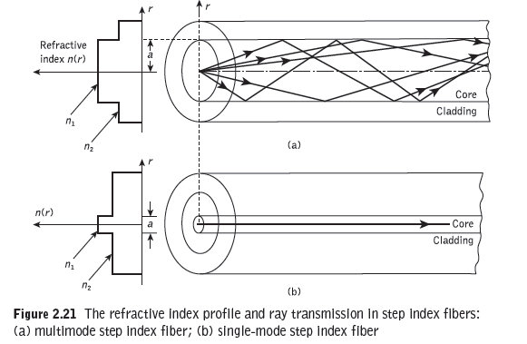

The single-mode step index fiber has the **distinct advantage of low intermodal dispersion** (broadening of transmitted light pulses), as only one mode is transmitted, whereas with multimode step index fiber considerable dispersion may occur due to the differing group velocities of the propagating modes. . Single mode fibers have a lower signal loss and a higher information capacity (bandwidth) than multimode fibers.

Multimode fibers offer several advantages compared with single mode fibers.

1. The larger core radii of multimode fibers make it easier to launch optical power into the fiber and facilitate the connecting together of similar fibers.
2. Light can be launched into a multimode fiber using LED source, where as single mode fibers must generally be excited with laser diodes. Although LEDs have less optical output power than laser diodes, they are easier to make, are less expensive, require less complex circuitry, and have longer lifetimes than laser diodes, thus making them more desirable in certain applications.

Multimode step index fibers allow the propagation of a finite number of guided modes along the channel. The number of guided modes is dependent upon the physical parameters (i.e. relative refractive index difference, core radius) of the fiber and the wavelengths of the transmitted light which are included in the normalized frequency *V* for the fiber.

An estimate of the number of guided modes propagating in a particular multimode step index fiber.



The normalized frequency range for single mode step index fiber is

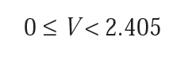

**Graded index fibers:**

**In Graded index fibers, refractive index is made to vary as a function of the radial distance from the center of the fiber.** i.e., core has maximum value of refractive index at its axis and the value decreases on radially moving away from the axis and decreases to a constant value in the cladding.

The refractive index profile is given by

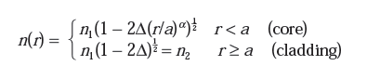

where **Δ** is the relative refractive index difference and

α is the profile parameter which gives the characteristic refractive index profile of the fiber core.

If α = ∞, R.I. profile is step index profile

α = 2, R.I. profile is parabolic profile

α = 1, R.I. profile is triangular profile

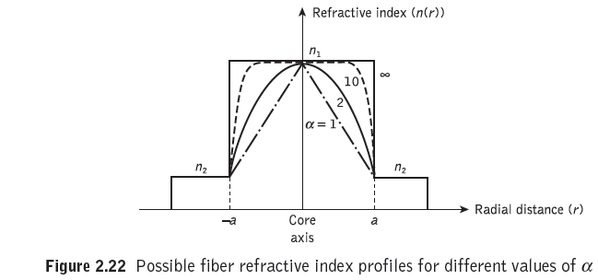

* The graded index profiles which at present produce the best results for multimode optical propagation have a near parabolic refractive index profile core with α = 2.
* Multimode graded index fibers exhibit less intermodal dispersion than multimode step index fibers due to their refractive index profile.

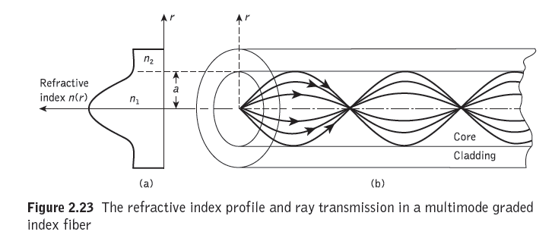

A multimode graded index fiber with a parabolic index profile core is illustrated in

Figure 2.23. Using the concepts of geometric optics, the gradual decrease in refractive index from the center of the core creates many refractions of the rays as they are effectively incident on a large number or high to low index interfaces. This mechanism is illustrated in Figure 2.24 where a ray is shown to be gradually curved, with an ever increasing angle of incidence, until the conditions for total internal reflection are met, and the ray travels back towards the core axis, again being continuously refracted.

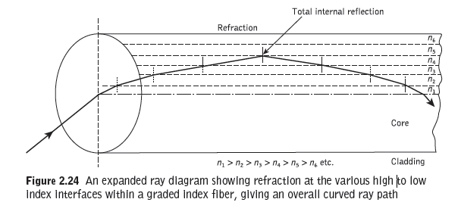

Number of modes is given by



Hence for a parabolic refractive index profile core fiber (α = 2), *M*g = *V* 2/4.

**For problems see your class notes**

**For fiber materials topic see your class notes**