**Unit-3**

**Optical emission from semiconductors:**

**The p–n junction:**

* A perfect semiconductor crystal containing no impurities or lattice defects is said to be **intrinsic.**
* The energy band structure of an intrinsic semiconductor is illustrated in  Figure 6.8(a) which shows the valence and conduction bands separated by a forbidden energy gap or band gap Eg, the width of which varies for different semiconductor materials.
* Figure 6.8(a) shows the situation in the semiconductor at a temperature above absolute zero where thermal excitation raises some electrons from the valence band into the conduction band, leaving empty hole states in the valence band.
* These thermally excited electrons in the conduction band and the holes left in the valence band allow conduction through the material, and are called carriers.
* For a semiconductor in thermal equilibrium the energy-level occupation is described by the Fermi–Dirac distribution function (rather than the Boltzmann).
* Consequently, the probability P(E) that an electron gains sufficient thermal energy at an absolute temperature T, such that it will be found occupying a particular energy level E, is given by the Fermi–Dirac distribution

http://www.faadooengineers.com/notes/images/2/18/a374f5d09104e24716890938dca7c01e1.png

where *K*is Boltzmann’s constant and *E*F is known as the Fermi energy or Fermi level.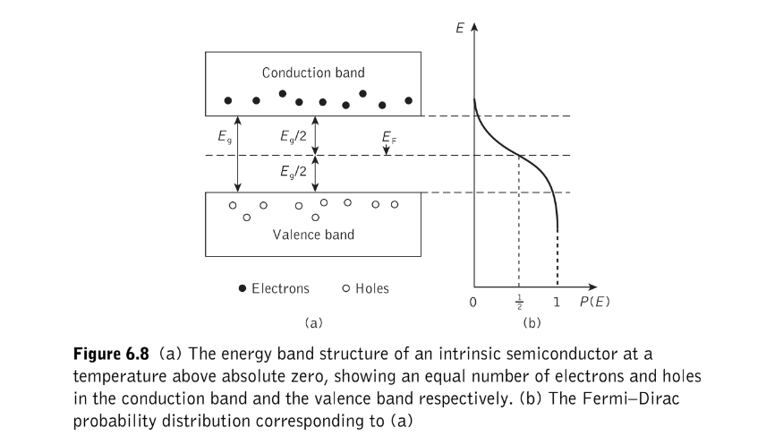

The Fermi level is only a mathematical parameter but it gives an indication of the distribution of carriers within the material. This is shown in Figure 6.8(b) for the intrinsic semiconductor where the Fermi level is at the center of the bandgap, indicating that there is a small probability of electrons occupying energy levels at the bottom of the conduction band and a corresponding number of holes occupying energy levels at the top of the valence band. 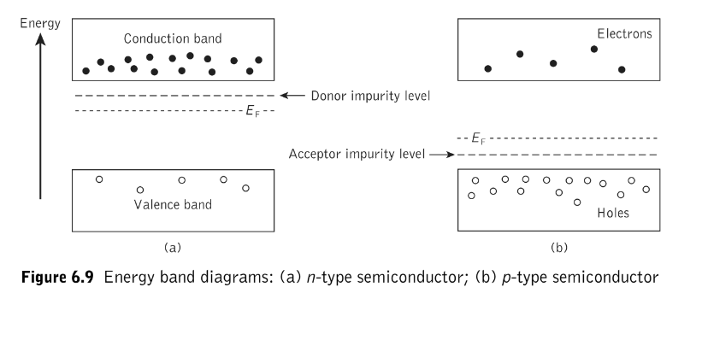

To create an extrinsic semiconductor the material is doped with impurity atoms which create either more free electrons (donor impurity) or holes (acceptor impurity). These two situations are shown in Figure 6.9 where the donor impurities form energy levels just below the conduction band while acceptor impurities form energy levels just above the valence band.

When donor impurities are added, thermally excited electrons from the donor levels are raised into the conduction band to create an excess of negative charge carriers and the semiconductor is said to be n-type, with the majority carriers being electrons. The Fermi level corresponding to this carrier distribution is raised to a position above the center of the bandgap, as illustrated in Figure 6.9(a). When acceptor impurities are added, as shown in Figure 6.9(b), thermally excited electrons are raised from the valence band to the acceptor impurity levels leaving an excess of positive charge carriers in the valence band and creating a p-type semiconductor where the majority carriers are holes. In this case Fermi level is lowered below the center of the bandgap.

The p–n junction diode is formed by creating adjoining p- and n-type semiconductor layers in a single crystal, as shown in Figure 6.10(a). A thin depletion region or layer is formed at the junction through carrier recombination which effectively leaves it free of mobile charge carriers (both electrons and holes). This establishes a potential barrier between the p- and n-type regions which restricts the interdiffusion of majority carriers from their respective regions, as illustrated in Figure 6.10(b). In the absence of an externally applied voltage no current flows as the potential barrier prevents the net flow of carriers from one region to another. When the junction is in this equilibrium state the Fermi level for the p- and n-type semiconductor is the same as shown Figure 6.10(b).

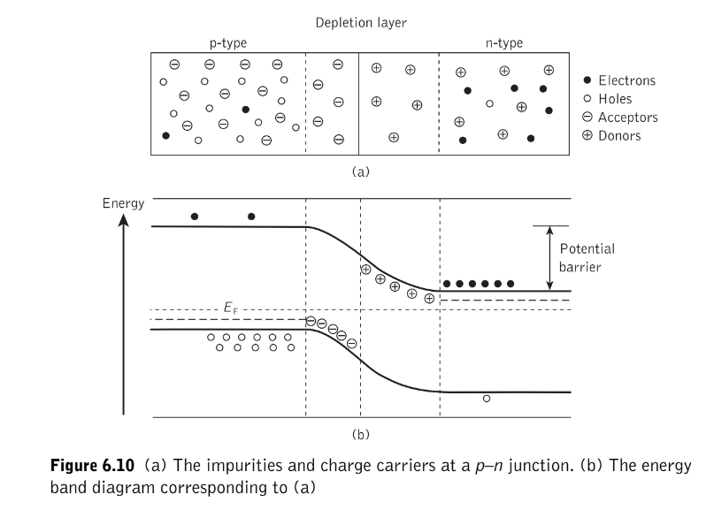

The width of the depletion region and thus the magnitude of the potential barrier is dependent upon the carrier concentrations (doping) in the p- and n-type regions and any external applied voltage.

When an external positive voltage is applied to the p-type region with respect to the n-type, both the depletion region width and the resulting potential barrier are reduced and the diode is said to be forward biased. Electrons from the n-type region and holes from the p-type region can flow more readily across the junction into the opposite type region. These minority carriers are effectively injected across the junction by the application of the external voltage and form a current flow through the device as they continuously diffuse away from the interface. However, this situation in suitable semiconductor materials allows carrier recombination with the emission-of-light.

**Spontaneous-emission:** 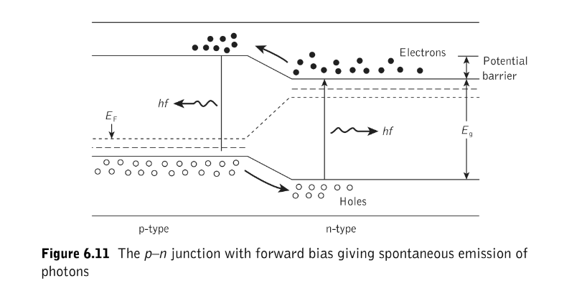

The increased concentration of minority carriers in the opposite type region in the forward-biased p–n diode leads to the recombination of carriers across the bandgap. This process is shown in Figure 6.11 for a direct bandgap semiconductor material where the normally empty electron states in the conduction band of the p-type material and the normally empty hole states in the valence band of the n-type material are populated by injected carriers which recombine across the bandgap. The energy released by this electron–hole recombination is approximately equal to the bandgap energy Eg.

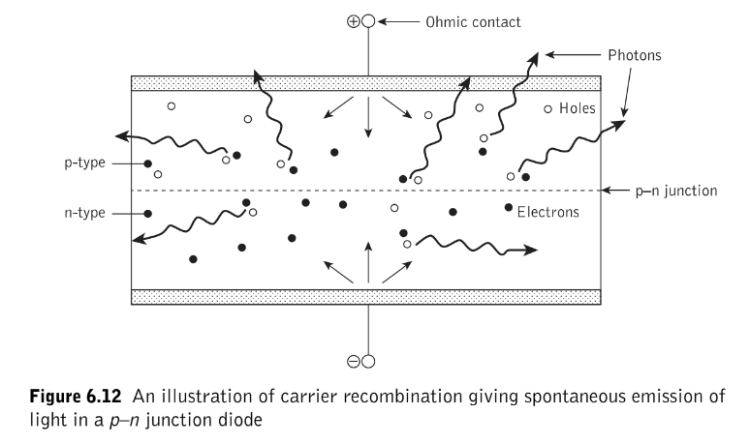

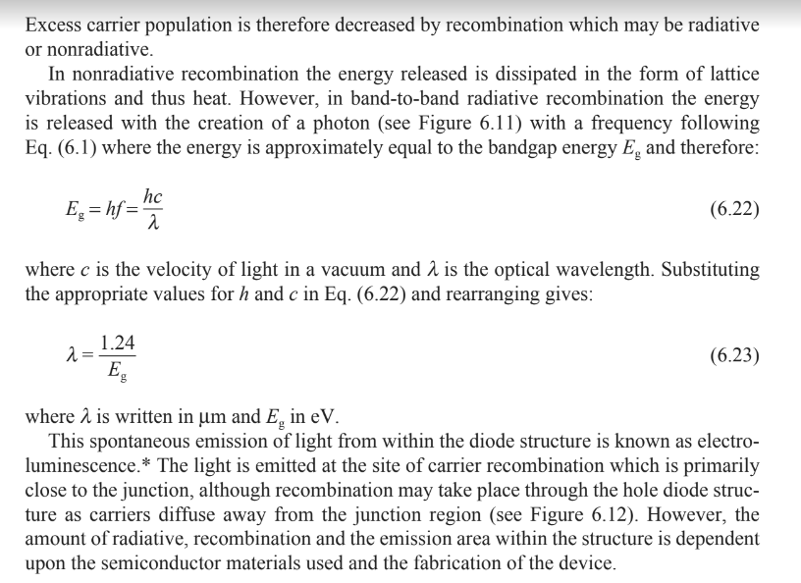

**Carrier recombination**

**Direct and indirect bandgap semiconductors**

In order to encourage electroluminescence it is necessary to select an appropriate semiconductor material. The most useful materials for this purpose are direct bandgap semiconductors in which electrons and holes on either side of the forbidden energy gap have the same value of crystal momentum and thus direct recombination is possible. This process is illustrated in Figure 6.13(a) with an energy–momentum diagram for a direct bandgap semiconductor. It may be observed that the energy maximum of the valence band occurs at the same (or very nearly the same) value of electron crystal momentum as the energy minimum of the conduction band. Hence when electron–hole recombination occurs the momentum of the electron remains virtually constant and the energy released, which corresponds to the bandgap energy Eg, may be emitted as light. This direct transition of an electron across the energy gap provides an efficient mechanism for photon emission and the average time that the minority carrier remains in a free state before recombination (the minority carrier lifetime) is short (10−8 to 10−10 s). Some commonly used direct bandgap semiconductor materials are shown in Table 6.1

In indirect bandgap semiconductors, however, the maximum and minimum energies occur at different values of crystal momentum (Figure 6.13(b)). For electron–hole recombination to take place it is essential that the electron loses momentum such that it has a value of momentum corresponding to the maximum energy of the valence band. The conservation of momentum requires the emission or absorption of a third particle, a phonon.

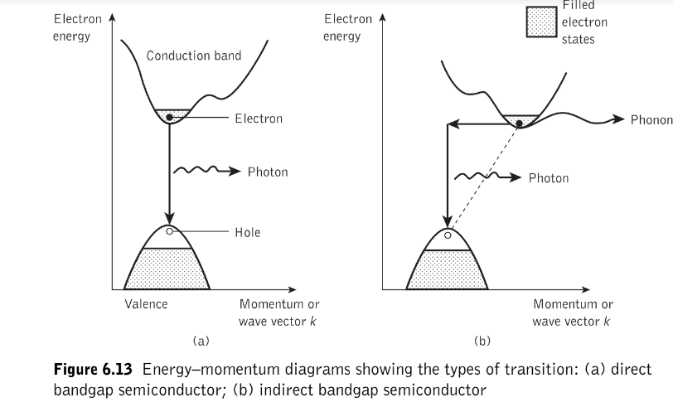

**Table 6.1 Some direct and indirect bandgap semiconductors with calculated**

**recombination coefficients**

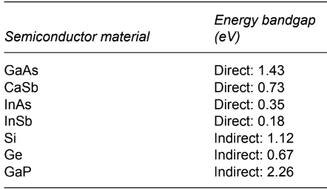

**Other radiative recombination processes:**

* Major radiative recombination processes at 300 K other than band-to-band transitions are shown in Figure 6.14. These are band to impurity center or impurity center to band, donor level to acceptor level and recombination involving isoelectronic impurities.

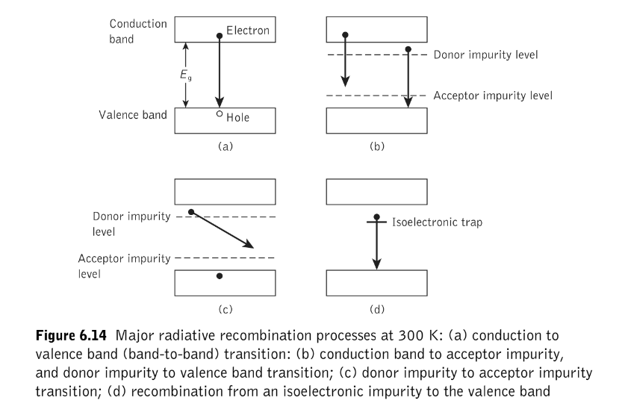

**Stimulated emission and lasing:**

* Carrier population inversion is achieved in an intrinsic (undoped) semiconductor by the injection of electrons into the conduction band of the material. This is illustrated in Figure 6.15 where the electron energy and the corresponding ﬁlled states are shown.
* Figure 6.15(a) shows the situation at absolute zero when the conduction band contains no electrons.
* Electrons injected into the material ﬁll the lower energy states in the conduction band up to the injection energy or the quasi-Fermi level for electrons.
* Since charge neutrality is conserved within the material, an equal density of holes is created in the top of the valence band by the absence of electrons, as shown in Figure 6.15(b) .
* Incident photons with energy Eg but less than the separation energy of the quasi-Fermi levels Eq = EFc − EFv cannot be absorbed because the necessary conduction band states are occupied.
* However, these photons can induce a downward transition of an electron from the ﬁlled conduction band states into the empty valence band states, thus stimulating the emission of another photon.
* The basic condition for stimulated emission is therefore dependent on the quasi-Fermi level separation energy as well as the bandgap energy and may be deﬁned as:

EFc − EFv > hf > Eg …………. (6.22)

* However, it must be noted that we have described an ideal situation whereas at normal operating temperatures the distribution of electrons and holes is less well deﬁned but the condition for stimulated emission is largely maintained.

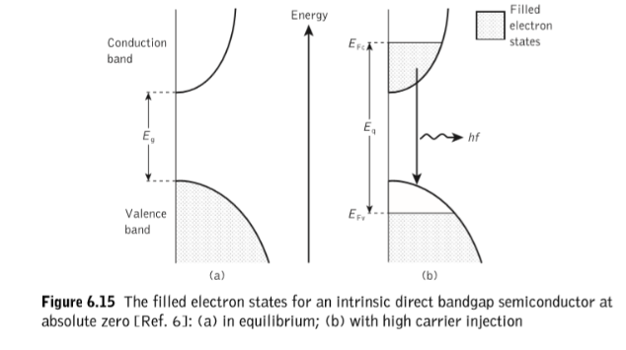

1. Population inversion may be obtained at a p–n junction by heavy doping (degenerative doping) of both the p- and n-type material.
2. Heavy p-type doping with acceptor impurities causes a lowering of the Fermi level or boundary between the ﬁlled and empty states into the valence band.
3. Similarly, degenerative n-type doping causes the Fermi level to enter the conduction band of the material.
4. Energy band diagrams of a degenerate p–n junction are shown in Figure 6.16. The position of the Fermi level and the electron occupation (shading) with no applied bias are shown in Figure 6.16(a). Since in this case the junction is in thermal equilibrium, the Fermi energy has the same value throughout the material.
5. Figure 6.16(b) shows the p–n junction when a forward bias nearly equal to the bandgap voltage is applied and hence there is direct conduction.
6. At high injection carrier density in such a junction there exists an active region near the depletion layer that contains simultaneously degenerate populations of electrons and holes (sometimes termed doubly degenerate).
7. For this region the condition for stimulated emission of Eq. (6.22) is satisﬁed for electromagnetic radiation of frequency Eg/h < f < (EFc − EFv)/h.
8. Therefore, any radiation of this frequency which is conﬁned to the active region will be ampliﬁed.
9. In general, the degenerative doping distinguishes a p–n junction which provides stimulated emission from one which gives only spontaneous emission as in the case of the LED.

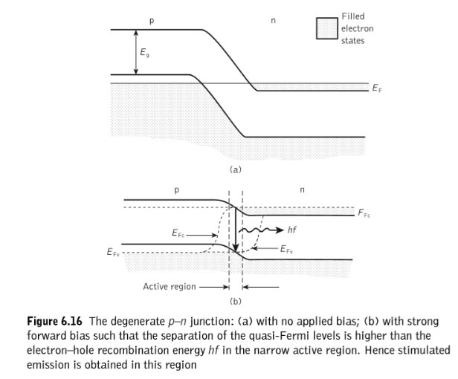

However, a further requirement of the junction diode is necessary to establish lasing. This involves the provision of optical feedback to give laser oscillation. It may be achieved by the formation of an optical cavity within the structure by polishing the end faces of the junction diode to act as mirrors. Each end of the junction is polished or cleaved and the sides are roughened to prevent any unwanted light emission and hence wasted population inversion.

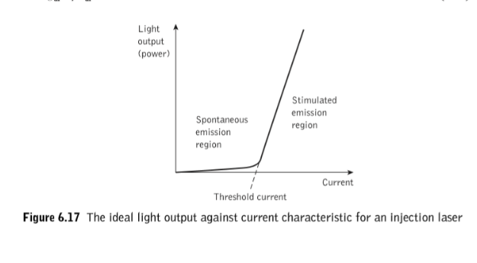

An idealized optical output power against current characteristic (also called light output against current characteristic) for a semiconductor laser is illustrated in Figure 6.17. It may be observed that the device gives little light output in the region below the threshold current which corresponds to spontaneous emission only within the structure. However, after the threshold current density is reached, the light output increases substantially for small increases in current through the device. This corresponds to the region of stimulated emission when the laser is acting as an ampliﬁer of light.

**Semiconductor injection laser (also called the injection laser diode (ILD) or simply the injection laser:**

Stimulated emission by the recombination of the injected carriers is encouraged in the semiconductor injection laser (also called the injection laser diode (ILD) or simply the injection laser) by the provision of an optical cavity in the crystal structure in order to provide the feedback of photons. This gives the injection laser several major advantages over other semiconductor sources (e.g. LEDs) that may be used for optical communications. These are as follows

**Advantages:**

1. High radiance due to the amplifying effect of stimulated emission. Injection lasers will generally supply milliwatts of optical output power.
2. Narrow linewidth on the order of 1 nm (10 Å) or less which is useful in minimizing the effects of material dispersion.
3. Modulation capabilities which at present extend up into the gigahertz range and will undoubtedly be improved upon.
4. Relative temporal coherence which is considered essential to allow heterodyne (coherent) detection in high-capacity systems, but at present is primarily of use in single-mode systems.
5. Good spatial coherence which allows the output to be focused by a lens into a spot which has a greater intensity than the dispersed unfocused emission. This permits efﬁcient coupling of the optical output power into the ﬁber even for ﬁbers with low numerical aperture.

The basic structure of this homojunction device is shown in Figure 6.19, where the cleaved ends of the crystal act as partial mirrors in order to encourage stimulated emission in the cavity when electrons are injected into the p-type region.

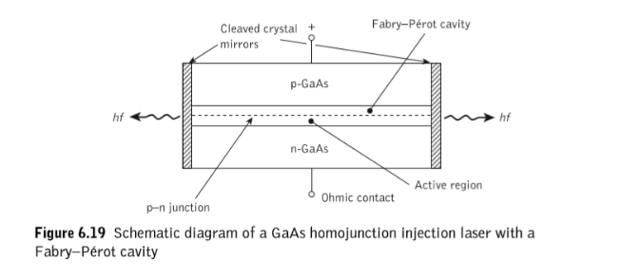

**Principle:**

It is specifically fabricated p-n junction diode. This diode emits laser light when it is forward biased. When a p-n junction diode is forward biased, the electrons from n – region and the holes from the p- region cross the junction and recombine with each other. During the recombination process, the light radiation (photons) is released from a certain specified direct band gap semiconductor like Ga-As. This light radiation is known as recombination radiation. The photon emitted during recombination stimulates other electrons and holes to recombine. As a result, stimulated emission takes place which produces laser.

Figure shows the energy level diagram of semiconductor laser.

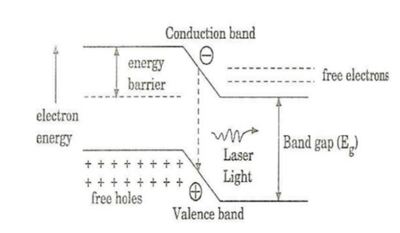

* When the PN junction is forward biased with large applied voltage, the electrons and holes are injected into junction region in considerable concentration. The region around the junction contains a large amount of electrons in the conduction band and a large amount of holes in the valence band. If the population density is high, a condition of population inversion is achieved. The electrons and holes recombine with each other and this recombination’s produce radiation in the form of light. When the forward – biased voltage is increased, more and more light photons are emitted and the light production instantly becomes stronger. These photons will trigger a chain of stimulated recombination resulting in the release of photons in phase. The photons moving at the plane of the junction travels back and forth by reflection between two sides placed parallel and opposite to each other and grow in strength. After gaining enough strength, it gives out the laser beam of wavelength 8400 A . The wavelength of laser light is given by

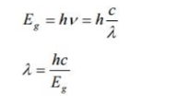

**Advantages:**

* It is very small in dimension. The arrangement is simple and compact.
* It exhibits high efficiency.
* The laser output can be easily increased by controlling the junction current
* It is operated with lesser power than ruby and CO2 laser.
* It requires very little auxiliary equipment
* It can have a continuous wave output or pulsed output.

**Disadvantages:**

* These devices had a high threshold current density due to their lack of carrier containment and proved inefﬁcient light sources.
* The output is usually from 5 degree to 15 degree i.e., laser beam has large divergence.

Improved carrier containment and thus lower threshold current densities were achieved using heterojunction structures

**Applications:**

* It is widely used in fiber optic communication
* It is used to heal the wounds by infrared radiation
* It is also used as a pain killer
* It is used in laser printers and CD writing and reading.

**Heterojunctions**

**Introduction:**

* A single p–n junction fabricated from a single-crystal semiconductor material is known as a **homojunction**
* However, the radiative properties of a junction diode may be improved by the use of heterojunctions.
* A **heterojunction** is an interface between two adjoining single crystal semiconductors with different band gap energies
* Heterojunctions are classified into either an isotype (n–n or p–p) or an anisotype (p–n).
* The iso-type heterojunction provides a potential barrier within the structure which is useful for the confinement of minority carriers to a small active region (carrier confinement).
* Alternatively, anisotype heterojunctions with sufﬁciently large bandgap differences improve the injection efﬁciency of either electrons or holes.
* Both types of heterojunction provide a dielectric step due to the different refractive indices at either side of the junction. This may be used to provide radiation conﬁnement to the active region (i.e. the walls of an optical waveguide). The efﬁciency of the conﬁnement depends upon the magnitude of the step which is dictated by the difference in bandgap energies and the wavelength of the radiation.

**DOUBLE-HETEROJUNCTION INJECTION LASER**

* When a double-heterojunction (DH) structure was implemented, the resulting carrier and optical conﬁnement reduced the threshold currents necessary for lasing by a factor of around 100. Thus stimulated emission was obtained with relatively small threshold currents (50 to 200 mA). The layer structure and an energy band diagram for a DH injection laser are illustrated in Figure 6.18**.**
* A heterojunction is shown either side of the active layer for laser oscillation. The forward bias is supplied by connecting a positive electrode of a supply to the p side of the structure and a negative electrode to the n side.
* When a voltage which corresponds to the bandgap energy of the active layer is applied, a large number of electrons (or holes) are injected into the active layer and laser oscillation commences.
* These carriers are conﬁned to the active layer by the energy barriers provided by the heterojunctions which are placed within the diffusion length of the injected carriers.
* It may also be observed from Figure 6.18(c) that a refractive index step (usually a difference of 5 to 10%) at the heterojunctions provides radiation containment to the active layer.
* In effect the active layer forms the center of a dielectric waveguide which strongly conﬁnes the electroluminescence within this region, as illustrated in Figure 6.18(c).

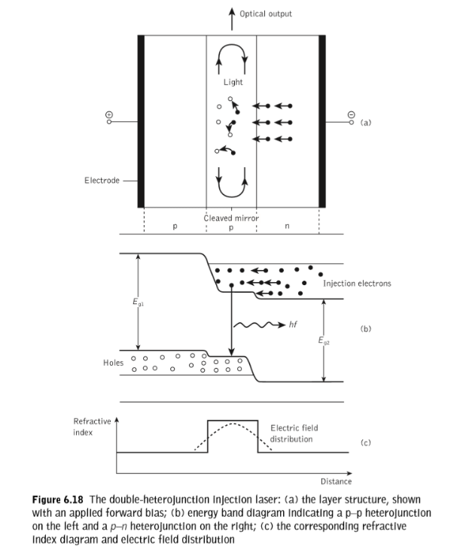

**Stripe geometry**

* The DH laser structure provides optical conﬁnement in the vertical direction through the refractive index step at the heterojunction interfaces, but lasing takes place across the whole width of the device.
* This situation is illustrated in Figure 6.20 which shows the broad-area DH laser where the sides of the cavity are simply formed by roughening the edges of the device in order to reduce unwanted emission in these directions and limit the number of horizontal transverse modes.
* However, the broad emission area creates several problems including difﬁcult heat sinking, lasing from multiple ﬁlaments in the relatively wide active area and unsuitable light output geometry for efﬁcient coupling to the cylindrical ﬁbers.

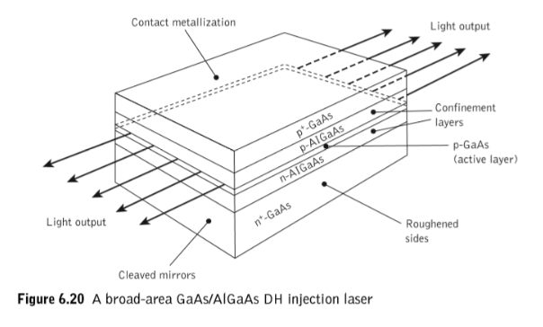

* To overcome these problems while also reducing the required threshold current, laser structures in which the active region does not extend to the edges of the device were developed. A common technique involved the introduction of stripe geometry to the structure to provide optical containment in the horizontal plane.
* The structure of a DH stripe contact laser is shown in Figure 6.21 where the major current ﬂow through the device and hence the active region is within the stripe.
* 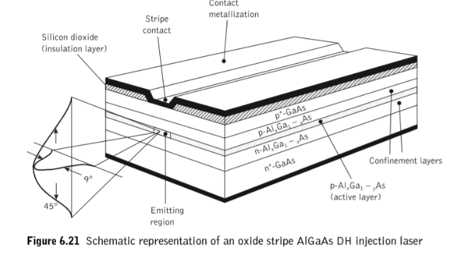Generally, the stripe is formed by the creation of high-resistance areas on either side by techniques such as proton bombardment or oxide isolation.
* The stripe therefore acts as a guiding mechanism which overcomes the major problems of the broad-area device.
* However, although the active area width is reduced the light output is still not particularly well collimated due to isotropic emission from a small active region and diffraction within the structure.
* The optical output and far-ﬁeld emission pattern are also illustrated in Figure 6.21.
* The output beam divergence is typically 45° perpendicular to the plane of the junction and 9° parallel to it. Nevertheless, this is a substantial improvement on the broad-area laser.