FACULTYPROFILE

Nameofthe Faculty: |  |  | Dr.M.V.N.Chakravarthi |  |  |  | 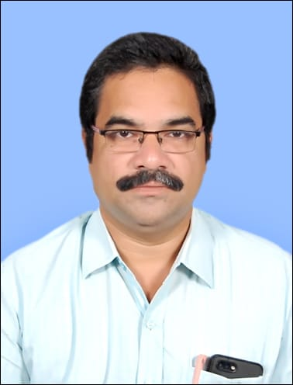
Designation: |  |  | Assistant Professor
Department: |  |  | EIE
Dateof Birth: |  |  | 25-07-1977
AICTE– ID: | 1-425600668
Education | - B.Tech in EIE from Bapatla Engineering College, Bapatla University/Institute in 2000.  - M.Tech in Digital Systems and Computer Electronics Specialization fromJNUTH,KukatpallyUniversity/Institute in 2008  - PhD in Signal Processing specialization from Acharya Nagarjuna University/Institute in 2023.
Experience | Teaching: 22 Years |  |  |  | Industry:____Years | Total: 22 Years
 | Research: ____Years |  |  |  | Others:____Years
ResearchSpecialization |  |  |  | Time Interleaved ADCs
Courses taught |  | 1. Analytical Instrumentation  2. Microcontrollers  3.Transducers  4.Optoelectronics and Laser Instrumentation  5.Industrial Instrumentation  6.Digital Electronics  7.Microprocessors etc
Research contributions

International/national peer reviewed journals
S. No. | Title of paper | Journal | Year | Volume | pages | Indexing (SCI/WoS/ SCOPUS, Google scholar)
1 | Calibration of Offsets in Time-Interleaved ADCs in an OFDM Receiver Using Differential Evolution Algorithm | Optoelectronics, Instrumentation and Data Processing | 2021 | 57 | 287-296 | SCOPUS
2 | Calibration of Mismatches in Time-Interleaved ADCs Using Teacher Learner-Based Optimization Algorithm. | Journal of Circuits, Systems and Computers | 2022 | 31(09) | p.2250163 | SCIE
3 | Optimization Algorithms based compensation of mismatches in Time interleaved Analog to Digital Converters-A Review | International journal of electrical and computer engineering systems | 2022 | 13(3) | 237-244 | SCOPUS

Bookspublished

S. No. | Title of the book | Publisher | year
1
Book chaptersPublished
S.No. | Title of the Chapter | Book title | Publisher | year
1 | Estimation of sampling time offsets in an N-channel time-interleaved ADC network using differential evolution algorithm and correction using fractional delay filters | Machine Intelligence and Signal Analysis | Springer Singapore | 2019
Details ofPatents(Filed&Granted)
S. No. | Applications number | Title of the patent | Date of filing/publishing | Published/granted
1
Details of Conferences/FDPs/STTPs/webinars/WorkshopsOrganized
S.No. | Name of the event | Role | Dates
1 | Conducted Workshop on "Vital Technologies of Industrial Automation: PLC & SCADA" by M/s.Techmation Solutions, Hyderabad. | Coordinator | 04-01-2023 to 06-01-2023
2 | Workshop on PLCs | Resource Person | 14-02-2020 to 15-02-2020
Details of Conferences/FDPs/STTPs/webinars/Workshops Participated
S.No. | Name of the event | Organized by | Dates
1 | 14th IEEE India Council International Conference (INDICON-2017) | IEEE, IIT Roorkee, India. | December 15-17, 2017
2 | International Conference on Machine Intelligence and Signal Processing, | IIT Indore, India. | December 22-24, 2017
Awards/recognitions/achievements
S.No. | Name of the Award | Awarding body/Society/Organization | Year
1 | PhD | Acharya Nagarjuna University | January,2023
Details of project proposals submitted/sanctioned/completed
S.No. | Title of the Project | Funding body | Submitted/ Sanctioned/ Completed | Amount | Year/ duration
 | -
Consultancy contribution
S.No. | Year | Amount | Details
1 | -
Student Project/research guidance
S.No | Level | Total number
1 | UG | Completed: 10 Ongoing:
2 | PG | Completed: -Ongoing:
3 | PhD | Completed: - Ongoing:
Administrative experience
S.No. | Role | Duration (From – to)
1 | I/C HOD | June,2023 to Till Date
Research credentials
Index/database | ID/Link
Google Scholar | https://scholar.google.com/citations?user=x9OQK6UAAAAJ&hl=en&oi=sra
SCOPUS | 57203500461
Web of Science | HHZ-2159-2022
Vidwan ID | https://vidwan.inflibnet.ac.in/profile/324401

Dr.M.V.N.Chakravarthi13-09-2023

