**Semiconductor photodiodes without internal gain:**

Semiconductor photodiodes without internal gain generate a single electron–hole pair per absorbed photon

**The p–n photodiode:**

Figure 8.4 shows a reverse-biased p–n photodiode with both the depletion and diffusion regions.

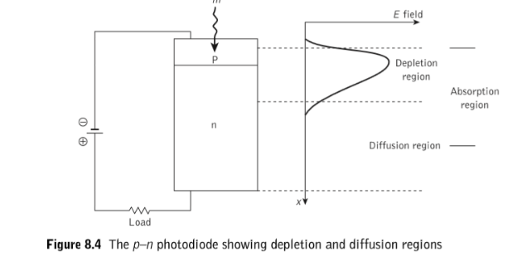

1. The depletion region is formed by immobile positively charged donor atoms in the n-type semiconductor material and immobile negatively charged acceptor atoms in the p-type material, when the mobile carriers are swept to their majority sides under the inﬂuence of the electric ﬁeld.
2. The width of the depletion region is therefore dependent upon the doping concentrations for a given applied reverse bias (i.e. the lower the doping, the wider the depletion region).
3. Photons may be absorbed in both the depletion and diffusion regions, as indicated by the absorption region in Figure 8.4. The absorption region’s position and width depend upon the energy of the incident photons and on the material from which the photodiode is fabricated. Thus in the case of the weak absorption of photons, the absorption region may extend completely throughout the device.
4. Electron–hole pairs are therefore generated in both the depletion and diffusion regions. In the depletion region the carrier pairs separate and drift under the inﬂuence of the electric ﬁeld, whereas outside this region the hole diffuses towards the depletion region in order to be collected.
5. The diffusion process is very slow compared with drift and thus limits the response of the photodiode.
6. It is therefore important that the photons are absorbed in the depletion region. Thus it is made as long as possible by decreasing the doping in the n-type material.
7. The depletion region width in a p–n photodiode is normally 1 to 3 μm and is optimized for the efﬁcient detection of light at a given wavelength. For silicon devices this is in the visible spectrum (0.4 to 0.7 μm) and for germanium in the near infrared (0.7 to 0.9 μm).

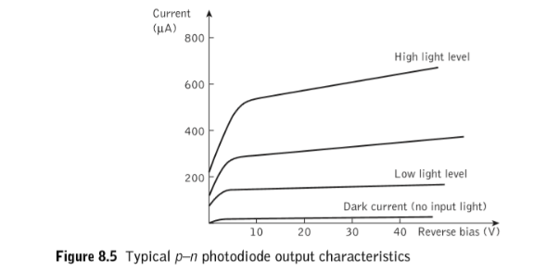

Typical output characteristics for the reverse-biased p–n photodiode are illustrated in Figure 8.5. The different operating conditions may be noted moving from no light input to a high light level.

**The p–i–n photodiode**

* The PIN photodiode provides additional sensitivity and performance over that of the basic PN junction photodiode.
* One of the key requirements for any photodetector is a sufficiently large area in which the light photons can be collected and converted. This is achieved by creating a large depletion region - the region where the light conversion takes place - by adding an intrinsic area into the PN junction to create a PIN junction.
* So, PIN photodiode is a device which consists of a p and n regions separated by a lightly doped intrinsic region.
* The cross-sectional view of p-i-n photodiode is as shown.

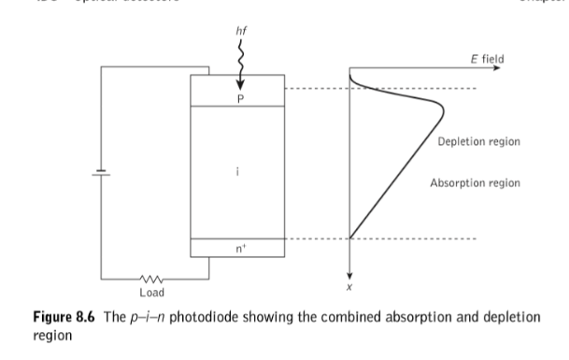

A sufficiently large reverse bias is applied across the device. When an incident photon has energy greater than or equal to the band gap energy of the semiconductor material, an electron excites from valence band to conduction band.

These carriers are mainly generated in the depletion region where most of the incident light is absorbed.

The high electric filed present in the depletion region causes the carriers to separate and be collected across the reverse biased junction. This gives rise to a current flow in the external circuit.

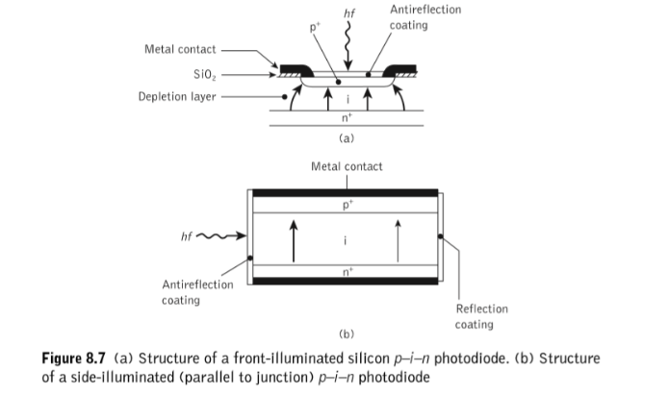

Figure 8.7 shows the structures of two types of silicon p–i–n photodiode.

The **front-illuminated photodiode**, when operating in the 0.8 to 0.9 μm band (Figure 8.7(a)), requires a depletion region of between 20 and 50 μm in order to attain high quantum efﬁciency (typically 85%) together with fast response (less than 1 ns) and low dark current (1 nA). Dark current arises from surface leakage currents as well as generation–recombination currents in the depletion region in the absence of illumination.

The **side-illuminated structure** (Figure 8.7(b)), where light is injected parallel to the junction plane, exhibits a large absorption width (500 μm) and hence is particularly sensitive at wavelengths close to the bandgap limit (1.09 μm) where the absorption coefﬁcient is relatively small.

**PIN photodiode applications**

The PIN photo-diode does not have any gain, and for some applications this may be a disadvantage. Despite this it is still the most widely used form of diode, finding applications in audio CD players, and DVD drives, etc. In addition to this they are used in optical communication systems.

**Semiconductor photodiodes with internal gain**

**Avalanche photodiodes:**

A major disadvantage of a p-n or a p-i-n diode is that each photon generates only one pair of electron and hole and there is no internal gain. Amplifying the output current after the detector stage introduces significant noise. One of the ways to deal with this problem is to design a detector with an internal gain. An avalanche photodiode (APD) is a device with internal gain which could be as high as 100. Si - APDs have sensitivities in the range 400 to 1100 nm while Ge-APDs have their spectral sensitivities in 800 to 1550 nm. InGaAs and InP APDs provide better sensitivity and spectral response.

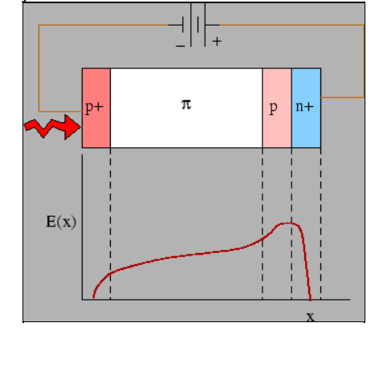

APDs are essentially p-n photodiodes operated under reverse bias near the breakdown voltage. The configuration consists of an n+ layer followed, in sequence, by (i) a thin p-layer, (ii) an intrinsic layer (in reality, a lightly doped p layer) and (iii) a heavily doped p-layer. The electric field distribution is shown. The field strength is maximum at the n+p junction

The electron- hole pair generated by light absorption remain separated by the electric field in the intrinsic region with the electrons drifting towards the lightly doped p-region and holes towards the p+ region. As an electron reach the region of strong electric field, it has a high kinetic energy. When such an energetic electron collides with the lattice, it may generate a new pair of electron and a hole. Such seceondary carriers may accelerate and create additional pairs leading to an avalanche cascade.