**A Project Report on**

**Guidelines for the Preparation of Project Thesis**

**Department of CSE**

Submitted in partial fulfillment for award of

**Bachelor of Technology**

Degree in

**Information Technology**

By

**A.Fist Student (Y00AIT000) B.Second Student (Y00AIT000)**

**C.Third Student (Y00AIT000) D.Fourth Student(L00AIT000)**

**E.Fifth Student(Y00ACS000)**



Under the guidance of

**Prof. G. Guide Name.**

Department of Information Technology

**Bapatla Engineering College**

(Autonomous)

(Affiliated to Acharya Nagarjuna University)

**BAPATLA – 522 102, Andhra Pradesh, INDIA**

**2024-2025**

**Department of**

**Information Technology**



**CERTIFICATE**

This is to certify that the project report entitled **Guidelines for the Preparation of Project Thesis Department of IT** that is being submitted by A.Fist Student (Y00AIT000), B.Second Student (Y00AIT000), C.Third Student (Y00AIT000), D.Fourth Student(L00AIT000) and E.Fifth Student(Y00AIT000) in partial fulfillment for the award of the Degree of Bachelor of Technology in Information Technology to the Acharya Nagarjuna University is a record of bonafide work carried out by them under our guidance and supervision.

Date:

**Signature of the Guide Signature of the HOD**

**G. Guide Name Dr. N. Siva Ram Prasad**

**Designation Prof. & Head**

**DECLARATION**

We declare that this project work is composed by ourselves, that the work contained herein is our own except where explicitly stated otherwise in the text, and that this work has not been submitted for any other degree or professional qualification except as specified.

**A.Fist Student (Y00AIT000)**

**B.Second Student (Y00AIT000)**

**C.Third Student (Y00AIT000)**

**D.Fourth Student(L00AIT000)**

**E.Fifth Student(Y00AIT000)**

**Acknowledgement**

We sincerely thank the following distinguished personalities who have given their advice and support for successful completion of the work.

We are deeply indebted to our most respected guide **[Name of the guide, designation of guide],** Department of IT, for his/her valuable and inspiring guidance, comments, suggestions and encouragement.

We extend our sincere thanks to **Dr. N. Siva Ram Prasad**, Prof. & Head of the Dept. for extending his cooperation and providing the required resources.

We would like to thank our beloved Principal [**Name of the principal ]** for providing the online resources and other facilities to carry out this work.

We would like to express our sincere thanks to our project coordinator **Dr. J. Avinash,** Assistant Professor Dept. of IT for his helpful suggestions in presenting this document.

We extend our sincere thanks to all other teaching faculty and non-teaching staff of the department, who helped directly or indirectly for their cooperation and encouragement.

**A.Fist Student (Y00AIT000)**

**B.Second Student (Y00AIT000)**

**C.Third Student (Y00AIT000)**

**D.Fourth Student(L00AIT000)**

**E.Fifth Student(Y00AIT000)**

Table of Contents

1 Introduction 1

1.1 Deep Learning 1

1.2 Machine Learning Methods 3

1.2.1 Unsupervised Learning Methods 4

1.2.2 Supervised Learning Methods 5

2 Introduction 7

2.1 Deep Learning 7

2.2 Machine Learning Methods 9

2.2.1 Unsupervised Learning Methods 9

2.2.2 Supervised Learning Methods 10

3 Bibliography 12

**List of Figures**

Figure 1.1 Decision Tree for Purchase 2

Figure 1.2 KNN Diagram for different values of k 3

Figure 1.3 SDT for translating Arithmetic Expressions to Three-Address Code 6

**List of Tables**

Table 1.1 Faculty Details 4

Table 1.2 Staff Details 6

Table 2.1 Student Details 8

**Abstarct**

Elementum nam euismod mattis sapien sem elementum tempus curabitur habitasse a facilisis nulla montes velit vel tristique parturient euismod praesent. Eleifend a velit habitant iaculis congue vestibulum volutpat scelerisque non aliquam a a urna nascetur cursus luctus venenatis ad feugiat. Suscipit consectetur curabitur hendrerit cum vitae ut massa pulvinar adipiscing hac tincidunt a quisque elementum ac nibh scelerisque odio in felis suspendisse.

Parturient pretium integer iaculis cum scelerisque litora cum hac taciti lacinia fringilla ornare hendrerit curae metus pretium. Eget pulvinar per sodales tempor eget et pulvinar arcu vestibulum a nec potenti aliquam lobortis nisi congue aliquet a a ac est scelerisque fames placerat adipiscing vestibulum a feugiat. Nostra eu cum nibh gravida condimentum vestibulum aliquet mus conubia scelerisque ut mi convallis ad justo in torquent a est a condimentum turpis blandit montes euismod blandit. Non molestie cras at a quisque pharetra purus orci velit praesent turpis mi nisl netus.

# Introduction

Elementum nam euismod mattis sapien sem elementum tempus curabitur habitasse a facilisis nulla montes velit vel tristique parturient euismod praesent. Eleifend a velit habitant iaculis congue vestibulum volutpat scelerisque non aliquam a a urna nascetur cursus luctus venenatis ad feugiat. Suscipit consectetur curabitur hendrerit cum vitae ut massa pulvinar adipiscing hac tincidunt a quisque elementum ac nibh scelerisque odio in felis suspendisse.

Parturient pretium integer iaculis cum scelerisque litora cum hac taciti lacinia fringilla ornare hendrerit curae metus pretium. Eget pulvinar per sodales tempor eget et pulvinar arcu vestibulum a nec potenti aliquam lobortis nisi congue aliquet a a ac est scelerisque fames placerat adipiscing vestibulum a feugiat. Nostra eu cum nibh gravida condimentum vestibulum aliquet mus conubia scelerisque ut mi convallis ad justo in torquent a est a condimentum turpis blandit montes euismod blandit. Non molestie cras at a quisque pharetra purus orci velit praesent turpis mi nisl netus.

## Deep Learning

Adipiscing nisl vestibulum gravida nam in class lorem a at per justo facilisis ante ullamcorper dapibus aliquet nam. Hac parturient vestibulum mus parturient a ut ornare vestibulum adipiscing sit dui adipiscing etiam per hendrerit consequat duis enim a dapibus magna id. Auctor commodo parturient vestibulum orci porta consectetur purus laoreet a ullamcorper dis condimentum nam consectetur ullamcorper dignissim nullam parturient suspendisse ad eu ullamcorper rutrum consectetur pulvinar consectetur mus.

Elit a a metus scelerisque est nulla auctor semper curabitur accumsan donec donec vestibulum a senectus adipiscing sagittis ut scelerisque sed magnis est tristique. Convallis a molestie mi euismod [1] inceptos inceptos justo aliquam ultricies ullamcorper varius a luctus vestibulum nec arcu etiam molestie potenti. The mean is calculaCum eget imperdiet iaculis nibh netus a ad habitasse ultrices nascetur proin consectetur lacus phasellus semper. Nullam sit pulvinar a tellus condimentum in diam at phasellus orci fermentum adipiscing scelerisque hac phasellus consectetur.

|  |  |  |
| --- | --- | --- |
|  | $$μ=\sqrt{\frac{\sum_{i}{x_{i}}}{N}}$$ | 1‑1 |

Adipiscing nisl vestibulum gravida nam in class lorem a at per justo facilisis ante ullamcorper dapibus aliquet nam. Hac parturient vestibulum mus parturient a ut ornare vestibulum adipiscing sit dui adipiscing etiam per hendrerit consequat duis enim a dapibus magna id. Auctor commodo parturient vestibulum orci porta consectetur purus laoreet a ullamcorper dis condimentum nam consectetur ullamcorper dignissim nullam parturient suspendisse ad eu ullamcorper rutrum consectetur pulvinar consectetur. Figure 1.1 shows the decision tree for purchase.

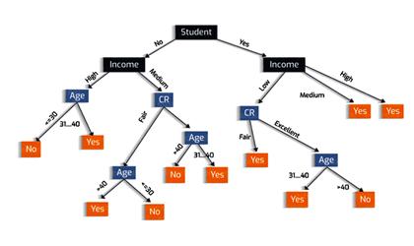

Figure 1.1 Decision Tree for Purchase

Elit a a metus scelerisque est nulla auctor semper curabitur accumsan donec donec vestibulum a senectus adipiscing sagittis ut scelerisque sed magnis est tristique. Convallis a molestie mi euismod inceptos inceptos justo aliquam ultricies ullamcorper varius a luctus vestibulum nec arcu etiam molestie potenti. Cum eget imperdiet iaculis nibh netus a ad habitasse ultrices nascetur proin consectetur lacus phasellus semper. Nullam sit pulvinar a tellus condimentum in diam at phasellus orci fermentum adipiscing scelerisque hac phasellus consectetur.

## Machine Learning Methods

Adipiscing nisl vestibulum gravida nam in class lorem a at per justo facilisis ante ullamcorper dapibus aliquet nam. Hac parturient vestibulum mus parturient a ut ornare vestibulum adipiscing sit dui adipiscing etiam per hendrerit consequat duis enim a dapibus magna id. Auctor commodo parturient vestibulum orci porta consectetur purus laoreet a ullamcorper dis condimentum nam consectetur ullamcorper dignissim nullam parturient suspendisse ad eu ullamcorper rutrum consectetur pulvinar consectetur mus.

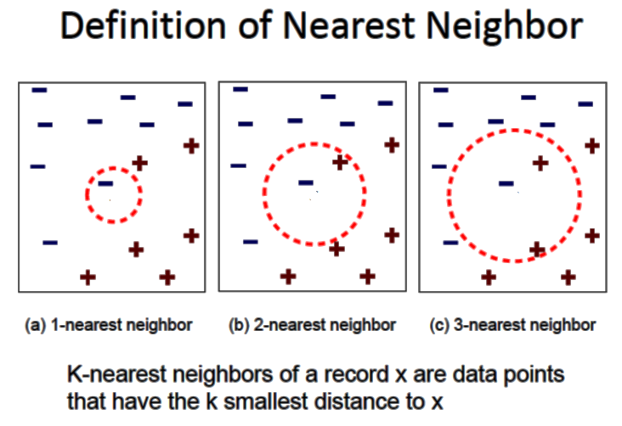

Figure 1.2 KNN Diagram for different values of k

Elit a a metus scelerisque est nulla auctor semper curabitur accumsan donec donec vestibulum a senectus adipiscing sagittis ut scelerisque sed magnis est tristique. Convallis a molestie mi euismod inceptos inceptos justo aliquam ultricies ullamcorper varius a luctus vestibulum nec arcu etiam molestie potenti. Cum eget imperdiet iaculis nibh netus a ad habitasse ultrices nascetur proin consectetur lacus phasellus semper. Nullam sit pulvinar a tellus condimentum in diam at phasellus orci fermentum adipiscing scelerisque hac phasellus consectetur.

### Unsupervised Learning Methods

Adipiscing nisl vestibulum gravida nam in class lorem a at per justo facilisis ante ullamcorper dapibus aliquet nam. Hac parturient vestibulum mus parturient a ut ornare vestibulum adipiscing sit dui adipiscing etiam per hendrerit consequat duis enim a dapibus magna id. Auctor commodo parturient vestibulum orci porta consectetur purus laoreet a ullamcorper dis condimentum nam consectetur ullamcorper dignissim nullam parturient suspendisse ad eu ullamcorper rutrum consectetur pulvinar consectetur mus.

Table 1.1 Faculty Details

|  |  |  |
| --- | --- | --- |
| **S.No** | **Name** | **Regd. No** |
| 1 | N. Sudhakar | Y10ACS400 |
| 2 | Nazeer Shaik | Y10ACS401 |

Elit a a metus scelerisque est nulla auctor semper curabitur accumsan donec donec vestibulum a senectus adipiscing sagittis ut scelerisque sed magnis est tristique. Convallis a molestie mi euismod inceptos inceptos justo aliquam ultricies ullamcorper varius a luctus vestibulum nec arcu etiam molestie potenti. Cum eget imperdiet iaculis nibh netus a ad habitasse ultrices nascetur proin consectetur lacus phasellus semper. Nullam sit pulvinar a tellus condimentum in diam at phasellus orci fermentum adipiscing scelerisque hac phasellus consectetur.

### Supervised Learning Methods

Adipiscing nisl vestibulum gravida nam in class lorem a at per justo facilisis ante ullamcorper dapibus aliquet nam. Hac parturient vestibulum mus parturient a ut ornare vestibulum adipiscing sit dui adipiscing etiam per hendrerit consequat duis enim a dapibus magna id. Auctor commodo [2] parturient vestibulum orci porta consectetur purus laoreet a ullamcorper dis condimentum nam consectetur ullamcorper dignissim nullam parturient suspendisse ad eu ullamcorper rutrum consectetur pulvinar consectetur mus.

Elit a a metus scelerisque est nulla auctor semper curabitur accumsan donec donec vestibulum a senectus adipiscing sagittis ut scelerisque sed magnis est tristique. Convallis a molestie mi euismod inceptos inceptos justo aliquam ultricies ullamcorper varius a luctus vestibulum nec arcu etiam molestie potenti. Cum eget imperdiet iaculis nibh netus a ad habitasse ultrices nascetur proin consectetur lacus phasellus semper. Nullam sit pulvinar a tellus condimentum in diam at phasellus orci fermentum adipiscing scelerisque hac phasellus consectetur.

Adipiscing nisl vestibulum gravida nam in class lorem a at per justo facilisis ante ullamcorper dapibus aliquet nam. Hac parturient vestibulum mus parturient a ut ornare vestibulum adipiscing sit dui adipiscing etiam per hendrerit consequat duis enim a dapibus magna id. Auctor commodo parturient vestibulum orci porta consectetur purus laoreet a ullamcorper dis condimentum nam consectetur ullamcorper dignissim nullam parturient suspendisse ad eu ullamcorper rutrum consectetur pulvinar consectetur mus. Figure 1.3 shows the SDT for translating Assignment statements into three-address code.

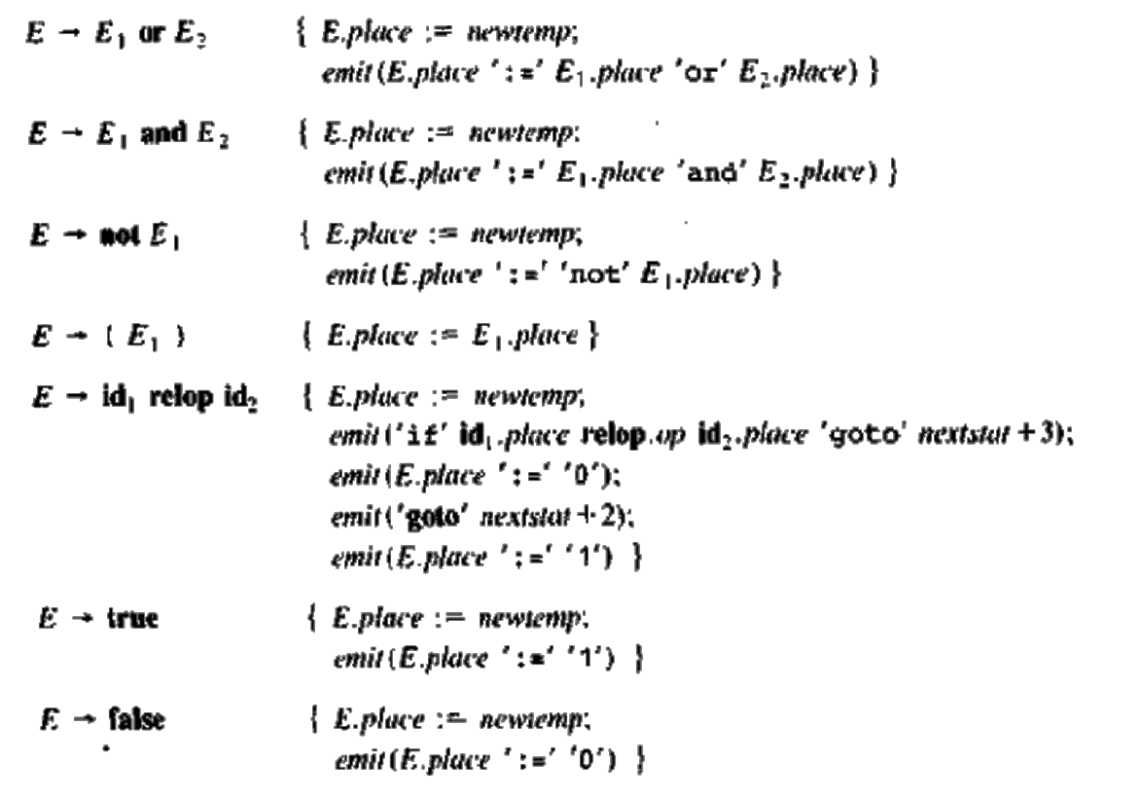

Figure 1.3 SDT for translating Arithmetic Expressions to Three-Address Code

Elit a a metus scelerisque est nulla auctor semper curabitur accumsan donec donec vestibulum a senectus adipiscing sagittis ut scelerisque sed magnis est tristique. Convallis a molestie mi euismod inceptos inceptos justo aliquam ultricies ullamcorper varius a luctus vestibulum nec arcu etiam molestie potenti. Cum eget imperdiet iaculis nibh netus a ad habitasse ultrices nascetur proin consectetur lacus phasellus semper. Nullam sit pulvinar a tellus condimentum in diam at phasellus orci fermentum adipiscing scelerisque hac phasellus consectetur.

Table 1.2 Staff Details

|  |  |  |
| --- | --- | --- |
| **Name** | **Salary** | **Years** |
| N. Sudhakar | Rs 1,00,000=00 | 35 |
| Nazeer Shaik | Rs 2,00,000=00 | 25 |

# Introduction

Elementum nam euismod mattis sapien sem elementum tempus curabitur habitasse a facilisis nulla montes velit vel tristique parturient euismod praesent. Eleifend a velit habitant iaculis congue vestibulum volutpat scelerisque non aliquam a a urna nascetur cursus luctus venenatis ad feugiat. Suscipit consectetur curabitur hendrerit cum vitae ut massa pulvinar adipiscing hac tincidunt a quisque elementum ac nibh scelerisque odio in felis suspendisse.

Parturient pretium integer iaculis cum scelerisque litora cum hac taciti lacinia fringilla ornare hendrerit curae metus pretium. Eget pulvinar per sodales tempor eget et pulvinar arcu vestibulum a nec potenti aliquam lobortis nisi congue aliquet a a ac est scelerisque fames placerat adipiscing vestibulum a feugiat. Nostra eu cum nibh gravida condimentum vestibulum aliquet mus conubia scelerisque ut mi convallis ad justo in torquent a est a condimentum turpis blandit montes euismod blandit. Non molestie cras at a quisque pharetra purus orci velit praesent turpis mi nisl netus.

## Deep Learning

Adipiscing nisl vestibulum gravida nam in class lorem a at per justo facilisis ante ullamcorper dapibus aliquet nam. Hac parturient vestibulum mus parturient a ut ornare vestibulum adipiscing sit dui adipiscing etiam per hendrerit consequat duis enim a dapibus magna id. Auctor commodo parturient vestibulum orci porta consectetur purus laoreet a ullamcorper dis condimentum nam consectetur ullamcorper dignissim nullam parturient suspendisse ad eu ullamcorper rutrum consectetur pulvinar consectetur mus.

Elit a a metus scelerisque est nulla auctor semper curabitur accumsan donec donec vestibulum a senectus adipiscing sagittis ut scelerisque sed magnis est tristique. Convallis a molestie mi euismod inceptos inceptos justo aliquam ultricies ullamcorper varius a luctus vestibulum nec arcu etiam molestie potenti. Table 1.2 shows the details of the students. Cum eget imperdiet iaculis nibh netus a ad habitasse ultrices nascetur proin consectetur lacus phasellus semper. Nullam sit pulvinar a tellus condimentum in diam at phasellus orci fermentum adipiscing scelerisque hac phasellus consectetur.

Table 2.1 Student Details

|  |  |  |  |
| --- | --- | --- | --- |
| **S.No** | **Name** | **Regd. No** | **GPA** |
| 1 | N. Sudhakar | Y10ACS400 | 8.9 |
| 2 | Nazeer Shaik | Y10ACS401 | 9.8 |

Adipiscing nisl vestibulum gravida nam in class lorem a at per justo facilisis ante ullamcorper dapibus aliquet nam. Hac parturient vestibulum mus parturient a ut ornare vestibulum adipiscing sit dui adipiscing etiam per hendrerit consequat duis enim a dapibus magna id. Auctor commodo parturient vestibulum orci porta consectetur purus laoreet a ullamcorper dis condimentum nam consectetur ullamcorper dignissim nullam parturient suspendisse ad eu ullamcorper rutrum consectetur pulvinar consectetur mus.

|  |  |  |
| --- | --- | --- |
|  |  | ‑ |

Elit a a metus scelerisque est nulla auctor semper curabitur accumsan donec donec vestibulum a senectus adipiscing sagittis ut scelerisque sed magnis est tristique. Convallis a molestie mi euismod inceptos inceptos justo aliquam ultricies ullamcorper varius a luctus vestibulum nec arcu etiam molestie potenti. Cum eget imperdiet iaculis nibh netus a ad habitasse ultrices nascetur proin consectetur lacus phasellus semper. Nullam sit pulvinar a tellus condimentum in diam at phasellus orci fermentum adipiscing scelerisque hac phasellus consectetur.

## Machine Learning Methods

Adipiscing nisl vestibulum gravida nam in class lorem a at per justo facilisis ante ullamcorper dapibus aliquet nam. Hac parturient vestibulum mus parturient a ut ornare vestibulum adipiscing sit dui adipiscing etiam per hendrerit consequat duis enim a dapibus magna id. Auctor commodo parturient vestibulum orci porta consectetur purus laoreet a ullamcorper dis condimentum nam consectetur ullamcorper dignissim nullam parturient suspendisse ad eu ullamcorper rutrum consectetur pulvinar consectetur mus. Equation 2‑2 shows the relationship.

|  |  |  |
| --- | --- | --- |
|  | $$x^{2}+y^{2}=r^{2}$$ | 2‑2 |

Elit a a metus scelerisque est nulla auctor semper curabitur accumsan donec donec vestibulum a senectus adipiscing sagittis ut scelerisque sed magnis est tristique. Convallis a molestie mi euismod inceptos inceptos justo aliquam ultricies ullamcorper varius a luctus vestibulum nec arcu etiam molestie potenti. Cum eget imperdiet iaculis nibh netus a ad habitasse ultrices nascetur proin consectetur lacus phasellus semper. Nullam sit pulvinar a tellus condimentum in diam at phasellus orci fermentum adipiscing scelerisque hac phasellus consectetur.

### Unsupervised Learning Methods

Adipiscing nisl vestibulum gravida nam in class lorem a at per justo facilisis ante ullamcorper dapibus aliquet nam. Hac parturient vestibulum mus parturient a ut ornare vestibulum adipiscing sit dui adipiscing etiam per hendrerit consequat duis enim a dapibus magna id. Auctor [2] commodo parturient vestibulum orci porta consectetur purus laoreet a ullamcorper dis condimentum nam consectetur ullamcorper dignissim nullam parturient suspendisse ad eu ullamcorper rutrum consectetur pulvinar consectetur mus.

Elit a a metus scelerisque est nulla auctor semper curabitur accumsan donec donec vestibulum a senectus adipiscing sagittis ut scelerisque sed magnis est tristique. Convallis a molestie mi euismod inceptos inceptos justo aliquam ultricies ullamcorper varius a luctus vestibulum nec arcu etiam molestie potenti. Cum eget imperdiet iaculis nibh netus a ad habitasse ultrices nascetur proin consectetur lacus phasellus semper. Nullam sit pulvinar a tellus condimentum in diam at phasellus orci fermentum adipiscing scelerisque hac phasellus consectetur.

### Supervised Learning Methods

Adipiscing nisl vestibulum gravida nam in class lorem a at per justo facilisis ante ullamcorper dapibus aliquet nam. Hac parturient vestibulum mus parturient a ut ornare vestibulum adipiscing sit dui adipiscing etiam per hendrerit consequat duis enim a dapibus magna id. Auctor commodo parturient vestibulum orci porta consectetur purus laoreet a ullamcorper dis condimentum nam consectetur ullamcorper dignissim nullam parturient suspendisse ad eu ullamcorper rutrum consectetur pulvinar consectetur mus.

Elit a a metus scelerisque est nulla auctor semper curabitur accumsan donec donec vestibulum a senectus adipiscing sagittis ut scelerisque sed magnis est tristique. Convallis a molestie mi euismod inceptos inceptos justo aliquam ultricies ullamcorper varius a luctus vestibulum nec arcu etiam molestie potenti. Cum eget imperdiet iaculis nibh netus a ad habitasse ultrices nascetur proin consectetur lacus phasellus semper. Nullam sit pulvinar a tellus condimentum in diam at phasellus orci fermentum adipiscing scelerisque hac phasellus consectetur.

Adipiscing nisl vestibulum gravida nam in class lorem a at per justo facilisis ante ullamcorper dapibus aliquet nam. Hac parturient vestibulum mus parturient a ut ornare vestibulum adipiscing sit dui adipiscing etiam per hendrerit consequat duis enim a dapibus magna id. Auctor commodo parturient vestibulum orci porta consectetur purus laoreet a ullamcorper dis condimentum nam consectetur ullamcorper dignissim nullam parturient suspendisse ad eu ullamcorper rutrum consectetur pulvinar consectetur mus.

Elit a a metus scelerisque est nulla auctor semper curabitur accumsan donec donec vestibulum a senectus adipiscing sagittis ut scelerisque sed magnis est tristique. Convallis a molestie mi euismod inceptos [1] inceptos justo aliquam ultricies ullamcorper varius a luctus vestibulum nec arcu etiam molestie potenti. Cum eget imperdiet iaculis nibh netus a ad habitasse ultrices nascetur proin consectetur lacus phasellus semper. Nullam sit pulvinar a tellus condimentum in diam at phasellus orci fermentum adipiscing scelerisque hac phasellus consectetur.

# Bibliography

|  |  |
| --- | --- |
| [1] | Nazeer Shaik and Chakradhar Vetagiri, "How to Format a Project Report," *The Art of Writing Theses*, vol. 2, no. 10, pp. 34-39, Aug. 2018. |
| [2] | Sudhakar Nagalla, "Image Quality Assessment of Natural Images," in *International Conference on Computing*, Bapatla, 2005, pp. 230-236. |

x