FACULTYPROFILE

Name of the Faculty: |  |  | Srinivasa Rao.Tirumalapudi |  |  |  | 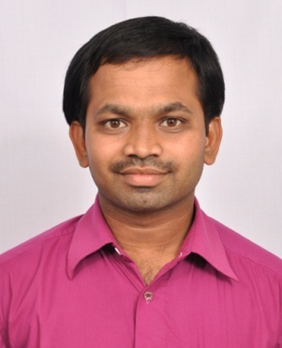
Designation: |  |  | Assistant Professor
Department: |  |  | Electronics & Instrumentation
Date of Birth: |  |  | 16-04-1982
AICTE– ID: | 1-425573685
Education | - B.Tech in Electronics & Communication from QIS CET, Ongole ,JNTUK, A.P in 2005.  - M.Tech in Communication & Signal Processing from Bapatla Engineering College, Bapatla, Acharya Nagarjuna University in 2007.
Experience | Teaching:15 Years |  |  |  | Industry: 0 Year | Total: 15 Years
 | Research: ____Years |  |  |  | Others:____Years
Research Specialization
Courses taught |  | 1.Electronic Devices  2. Electronic circuit theory  3.Digital Electronics  4.Electrical & Electronic measurements  5. Linear Control systems  6.Constituion of India  7.Prfoessionl Ethics & Human Values  8.Digital Image Processing  9. Optoelectronics & Laser Instrumentation.
Research contributions

International/national peer reviewed journals

S. No. | Title of paper | Journal | Year | Volume | pages | Indexing (SCI/WoS/ SCOPUS, Google scholar)
1 | PASSWORD BASED CIRCUIT BREAKER | Journals of Engineering Sciences | June-2020 | Vol 11 ,Issue 6, | ISSN NO :0377-9254

Books published

S. No. | Title of the book | Publisher | year
1 | nil

Book chaptersPublished

S.No. | Title of the Chapter | Book title | Publisher | year
1 | nil

Details of Patents (Filed & Granted)

S. No. | Applications number | Title of the patent | Date of filing/publishing | Published/granted
1 | nil

Details of Conferences/FDPs/STTPs/webinars/Workshops Organized

S.No. | Name of the event | Role | Dates
1 | nil

Details of Conferences/FDPs/STTPs/webinars/Workshops Participated

S.No. | Name of the event | Organized by | Dates
1 | FDP On Matlab tools and their applications | Data Teach Lab | 25-05-2020 to 07-06-2020
2 | Teacher Training Program by APSCHE – British Council English Communication Skills Project. | APSCHE | 10-07-2017 to 14-07-2017 and 24-07-2017 to 28-07-2017
3 | Digital Image Processing | NPTEL,IIT Kharagpur. | JULY-OCT-2022

Awards/recognitions/achievements

S.No. | Name of the Award | Awarding body/Society/Organization | Year
1 | …… | …… | ……

Details of project proposals submitted/sanctioned/completed

S.No. | Title of the Project | Funding body | Submitted/ Sanctioned/ Completed | Amount | Year/ duration
 | nil

Consultancy contribution

S.No. | Year | Amount | Details
1 | nil

Student Project/research guidance

S.No | Level | Total number
1 | UG | Completed: 10 Ongoing:
2 | PG | Completed: Ongoing:
3 | PhD | Completed: Ongoing:

Administrative experience

S.No. | Role | Duration (From – to)
1 | Training & Placement Department coordinator | 4 Years

Research credentials

Index/database | ID/Link
Google Scholar | …..
SCOPUS | …..
Web of Science | …..
Vidwan ID | …..

Any other relevant information

SrinivasaRao.T
14-09-2023

