FACULTYPROFILE

Name of the Faculty: |  |  | PRAMEELA GARIKAPATI |  |  |  | 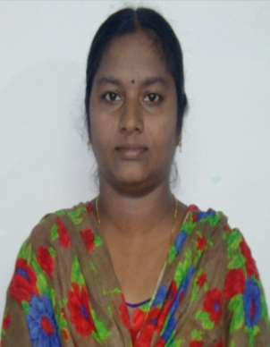  Photo
Designation: |  |  | ASSISTANT PROFESSOR
Department: |  |  | Electronics & Instrumentation
Date of Birth: |  |  | 16/08/1990
AICTE– ID:
Education | - B.Tech in Electronics & Instrumentation from Bapatla Engineering college, bapatla in 2011  - M.Tech in VLSI and Embedded systems from MaIineni lakshmaiah engineering college, singaraya konda in 2019
Experience | Teaching:_7___Years |  |  |  | Industry:____Years | Total:__07___Years
 | Research: ____Years |  |  |  | Others:____Years
ResearchSpecialization
Courses taught |  | 1.switching theory and logic design  2.micro processor and micro controller  3.electronic devices and circuits  4.Bio-medical instrumentation  5.micro controller  6.digital electronics  7.electronic measurements
Research contributions

International/national peer reviewed journals

S. No. | Title of paper | Journal | Year | Volume | pages | Indexing (SCI/WoS/ SCOPUS, Google scholar)
1
2 | NILL
3

Bookspublished

S. No. | Title of the book | Publisher | year
1

Book chaptersPublished

S.No. | Title of the Chapter | Book title | Publisher | year
1

Details ofPatents(Filed&Granted)

S. No. | Applications number | Title of the patent | Date of filing/publishing | Published/granted
1

Details of Conferences/FDPs/STTPs/webinars/WorkshopsOrganized

S.No. | Name of the event | Role | Dates
1

Details of Conferences/FDPs/STTPs/webinars/Workshops Participated

S.No. | Name of the event | Organized by | Dates
1 | Artificial intelligence | CBIT | 22-26 May,2020
2 | Principles of modern RADAR | RISE | 03/06/2020 to 07/06/2020
3 | Data science using machine learning algorithms | SVR | 26/05/2020
4 | Cutting-Edge Technologies | ALIE | 18/05/2020 TO 20/05/2020
5 | AI and IOT | GMR | 01/03/2020

Awards/recognitions/achievements

S.No. | Name of the Award | Awarding body/Society/Organization | Year
1

Details of project proposals submitted/sanctioned/completed

S.No. | Title of the Project | Funding body | Submitted/ Sanctioned/ Completed | Amount | Year/ duration

Consultancy contribution

S.No. | Year | Amount | Details
1

Student Project/research guidance

S.No | Level | Total number
1 | UG | Completed: Ongoing:
2 | PG | Completed: Ongoing:
3 | PhD | Completed: Ongoing:

Administrative experience

S.No. | Role | Duration (From – to)
1

Research credentials

Index/database | ID/Link
Google Scholar
SCOPUS
Web of Science
Vidwan ID

Any other relevant information

G.PRAMEELA
(Date)

